Evan Lyle’s Official Pool Club Management Software User Manual

Contents

Introduction 3

Start Menu 4

Staff Organization 5

Select Treeview Record 8

Adding a Staff Member Record 9

Removing a Staff Member Record 10

Updating a Staff Member Record 12

Clearing the Staff Member Entry Fields 14

Schedule Maintenance 15

Select Treeview Record 18

Adding a Maintenance Task Record 19

Removing a Maintenance Task Record 21

Updating a Maintenance Task Record 24

Clearing the Maintenance Task Entry Fields 26

Daily Readings 28

Select Treeview Record 30

Adding a Daily Reading Record 32

Removing a Daily Reading Record 33

Updating a Daily Reading Record 36

Clearing the Daily Reading Entry Fields 38

Generating a Daily Readings Water Quality Regulation Report 39

Weekly Readings 40

Select Treeview Record 42

Adding a Weekly Reading Record 43

Removing a Weekly Reading Record 44

Updating a Weekly Reading Record 47

Clearing the Weekly Reading Entry Fields 49

Generating a Weekly Readings Water Quality Regulation Report 50

Pool Chemical Supply 51

Select Treeview Record 52

Adding a Pool Chemical Record 53

Removing a Pool Chemical Record 54

Updating a Pool Chemical Record 57

Clearing the Pool Chemical Entry Fields 59

Staff Scheduling 60

Select Treeview Record 62

Adding a Staff Schedule Record 63

Removing a Staff Schedule Record 64

Updating a Staff Schedule Record 67

Clearing the Staff Schedule Entry Fields 69

# Introduction

There is a need to develop an application to assist in swimming pool club management using modern technologies such as Python and MySQL. Too many pool clubs around the country have been plagued with mismanagement, causing irregular hours for pool staff and the management of chemicals (like the pH levels) to be ignored. Many pool clubs exceed their budget due to overusing pool chemicals, running short of pool chemicals, and mismanaging lifeguard scheduling. Additionally, pools are frequently inspected by local health departments. Many times, pools are not prepared for these inspections due to incomplete or missing documentation concerning water testing and licensing certifications resulting in temporary closure.

Fortunately, this user manual will guide you on how to properly use this software in order to better manage your pool club (at least in the state of Maryland).

# Start Menu

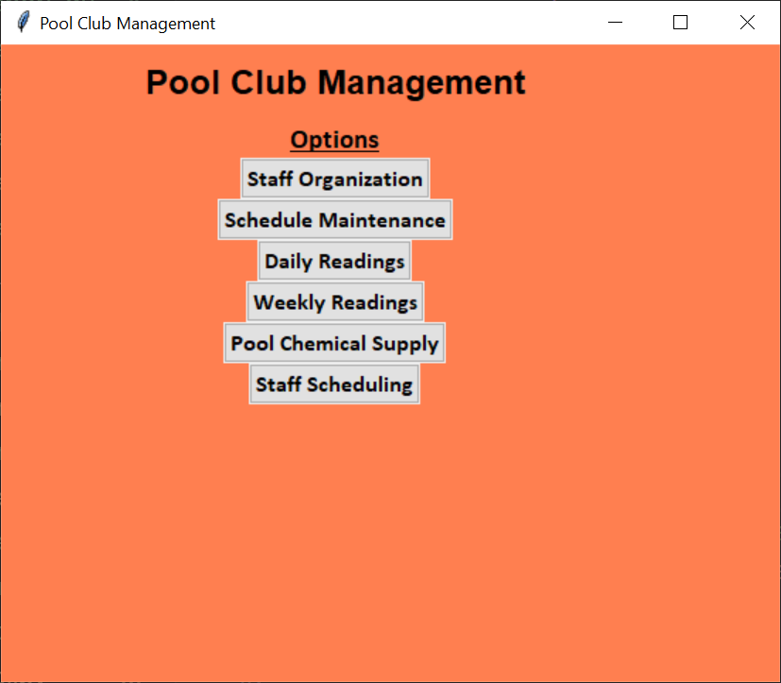

Figure – Start Menu

To access any of the other GUI screens, it is important to first understand the preliminary screen and where each button takes the user to.

|  |  |
| --- | --- |
| Button | Action |
| Staff Organization | Takes the user to the Staff Organization GUI. |
| Schedule Maintenance | Takes the user to the Schedule Maintenance GUI. |
| Daily Readings | Takes the user to the Daily Readings GUI. |
| Weekly Readings | Takes the user to the Weekly Readings GUI. |
| Pool Chemical Supply | Takes the user to the Pool Chemical Supply GUI. |
| Staff Scheduling | Takes the user to the Staff Scheduling GUI. |

Table - Start Menu buttons and their functions.

# Staff Organization

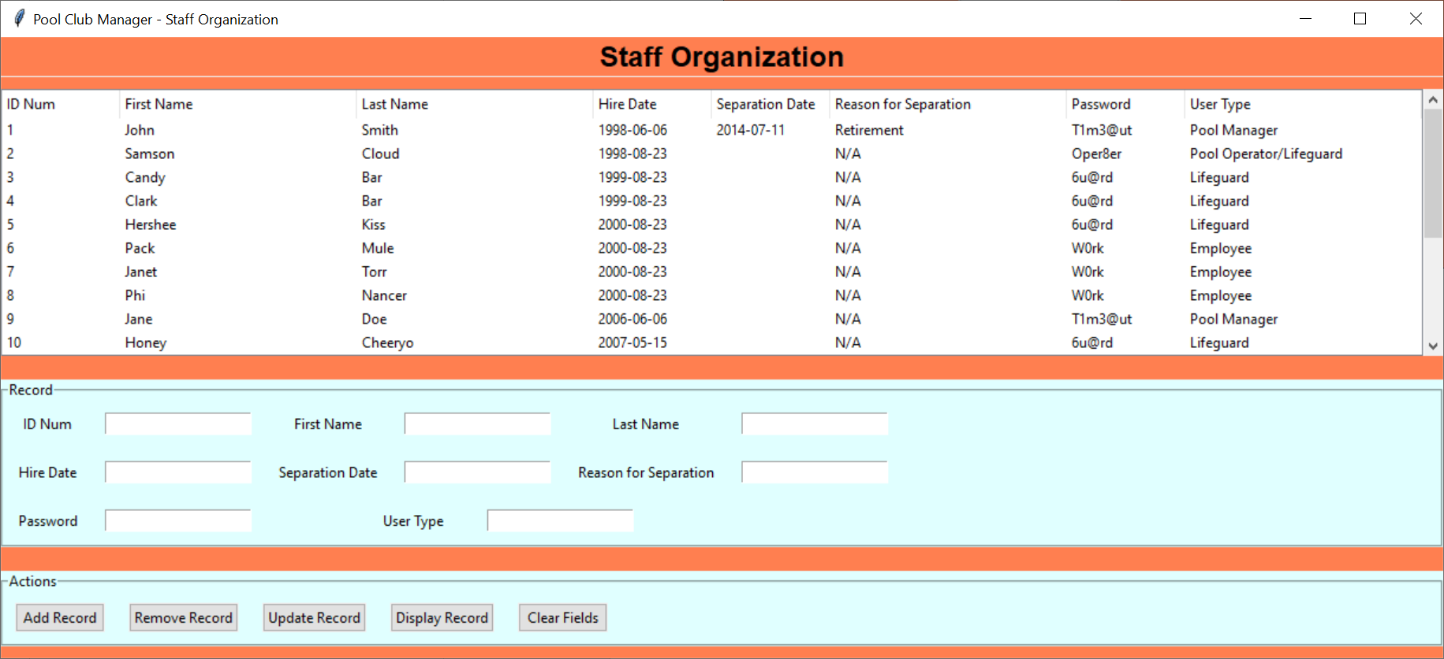

Figure – Staff Organization GUI

The Staff Organization GUI corresponds to the ‘staff’ MySQL table in the database. Figure 3 shows an example of the populated database, while Figure 4 shows the various fields that compose the table.

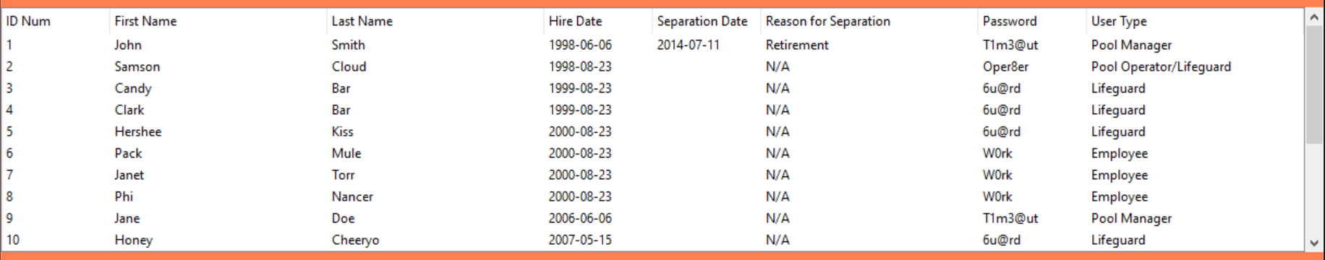

Figure – Treeview of the ‘staff’ table

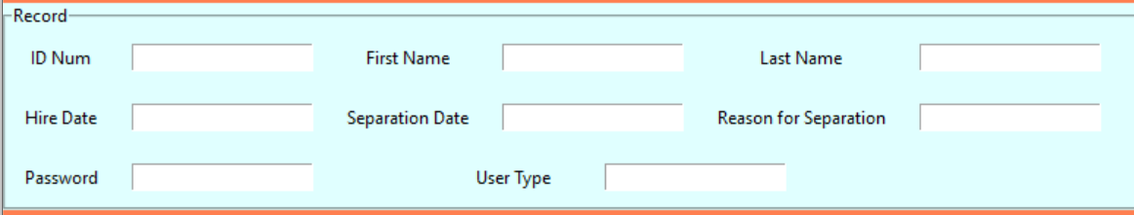

Figure – Input fields and labels

The input fields, their purpose, and their relationship to the ‘staff' table are listed in the table below.

|  |  |  |
| --- | --- | --- |
| Field | Purpose | Corresponding MySQL Variable |
| ID Num | The unique ID number for a staff member. | id_num |
| First Name | The first name of the staff member. | firstname |
| Last Name | The last name of the staff member. | lastname |
| Hire Date | The date that staff member was hired. | hiredate |
| Separation Date | The date that staff member was no longer part of the pool club. If the staff member in question is still with the pool club, leave the date blank. | separationdate |
| Reason for Separation | The reason a staff member was no longer part of the pool club. It could be for either amicable reasons or because they were fired. If the staff member has not left yet, put the value ‘N/A’ in this field. | reasonforseparation |
| Password | This the user password of the staff member. | password |
| User Type | This is the type of user the staff member is. They can be a Pool Manager, a Pool Operator/Lifeguard, a Lifeguard, or a general-purpose Employee.  In later iterations of this program, the difference in these User Types will affect the permissions of what the user can do with this software. | usertype |

Table – Entry Fields of the Staff Organization GUI

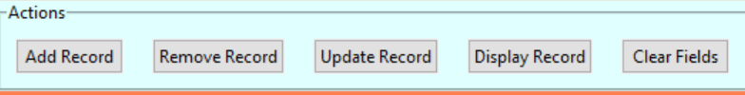

Figure – Action buttons

The following table describes the functions of each button in the Staff Organization GUI in relation to the ‘staff’ table and the program.

|  |  |  |
| --- | --- | --- |
| Button | Action | Program Equivalent |
| Add Record | Adds a record to the ‘staff’ table of the database based on the values in the input fields. | Calls upon the addRecord() function in poolclub_staff_gui.py, which calls upon the addStaffMember() function in the staff_api.py file. |
| Remove Record | Removes a record from the ‘staff’ table of the database corresponding to the value in the ID Num entry field. | Calls upon the removeRecord() function in poolclub_staff_gui.py, which calls upon the removeStaffMember() function in the staff_api.py file. |
| Update Record | Updates a record present in the ‘staff’ table of the database corresponding to the value of the ID Num entry field and using data in the other entry fields to modify said record. | Calls upon the updateRecord() function in poolclub_staff_gui.py, which calls upon the updateStaffMember() function in the staff_api.py file. |
| Display Records | Currently activates a pop-up window with a check box labeled “ID Num.” Future iterations of this program will have said pop-up window give the user the ability to filter the treeview to only display records matching certain parameters. | Calls upon the displayRecords() function in the poolclub_staff_gui.py file, which generates a pop-up window with a single checkbox labeled “ID Num.” |
| Clear Fields | Clears out the entry fields, leaving them all blank. | Calls upon the clear_entries() function in the poolclub_staff_gui.py file, which clears out the entry fields. |

Table – Functions of the Actions buttons in Staff Organization.

## Select Treeview Record

To select a treeview record, simply click on any variable in that row and the whole thing will be highlighted. Note that this behavior also automatically fills the record fields below with data corresponding to said record. This is shown in Figure 6 down below.

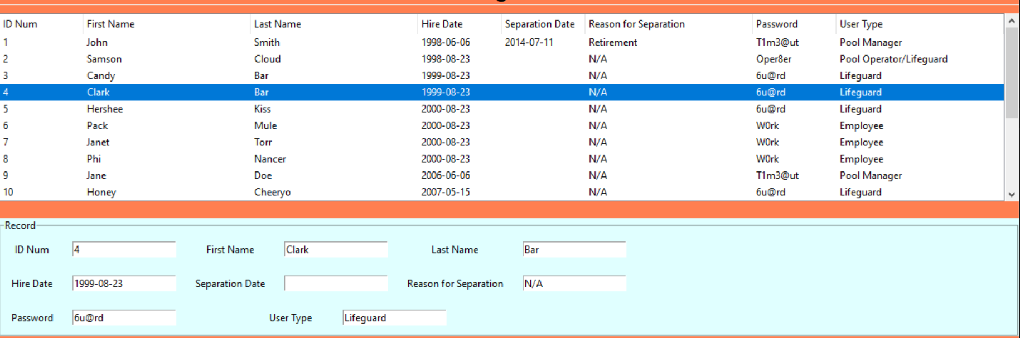

Figure – Selecting the staff member 'Clark Bar' from the treeview.

## Adding a Staff Member Record

First, you need to fill in the fields for the record of the new staff member you wish to add to the database located under the Record section of the GUI. Remember to make the ID Num field a unique value. Next, click on the **Add Record** button located under the Actions section of the GUI.

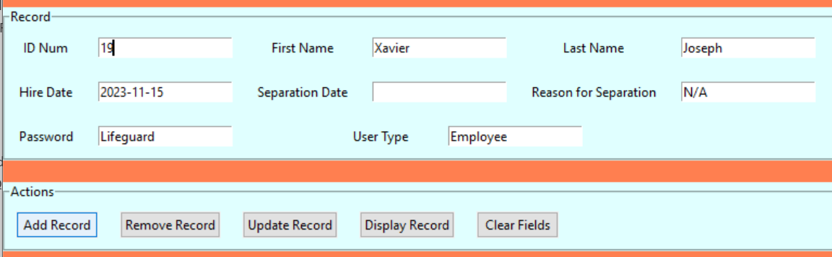

Figure 7 – Adding staff member 19 to the database.

Your new record should now be present in the GUI.

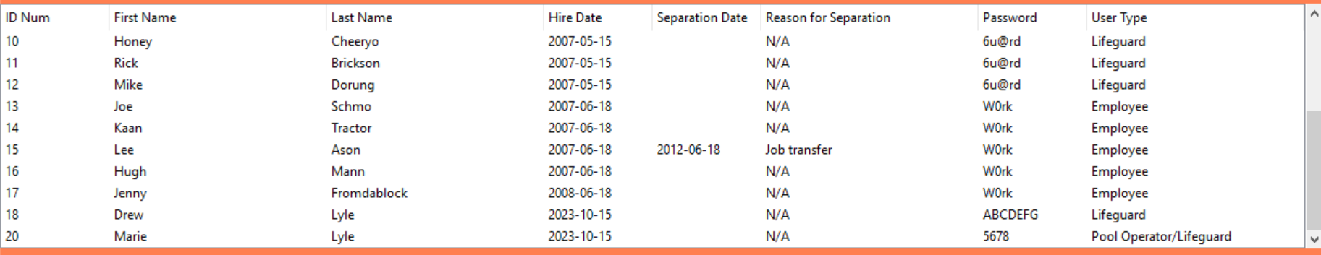

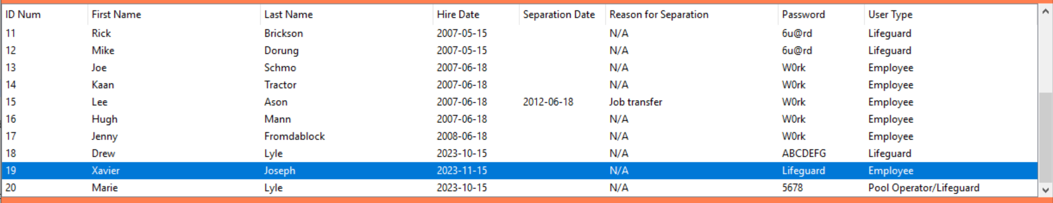

Figure 8 – The treeview of the staff table, before and after adding the staff member with the ID Num of 19 to the table.

## Removing a Staff Member Record

There are two ways to go about removing a staff member from the database. The first method is as follows:

1. Select the row in the treeview of the staff member you wish to delete.
2. Click the **Remove Record** button under the Actions section of the GUI.

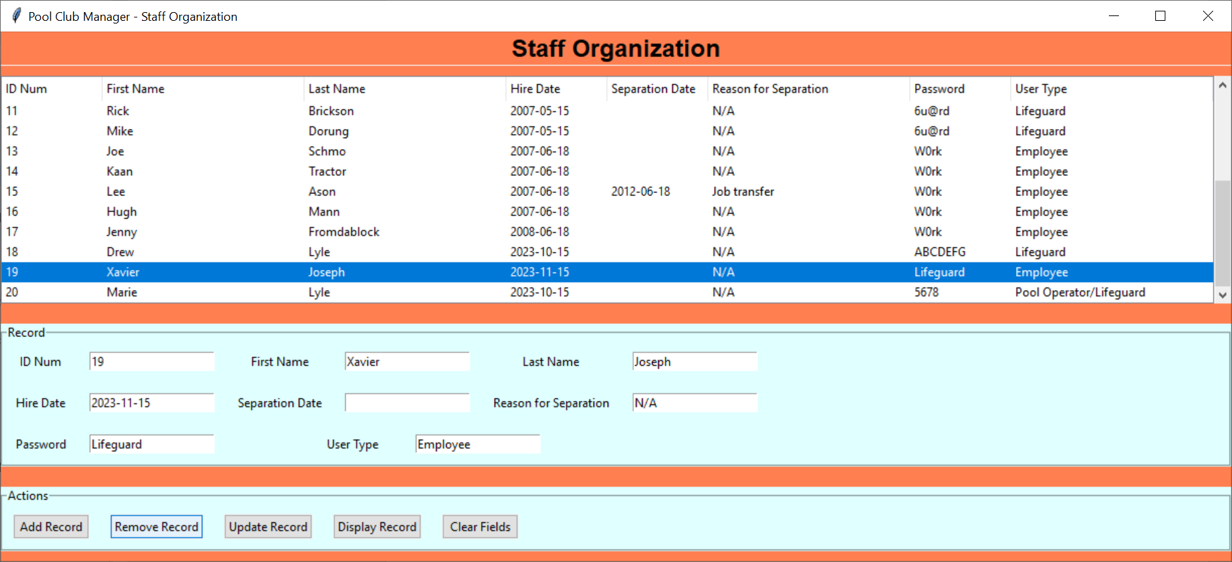

Figure 9 – A visualization of the first method to remove a record.

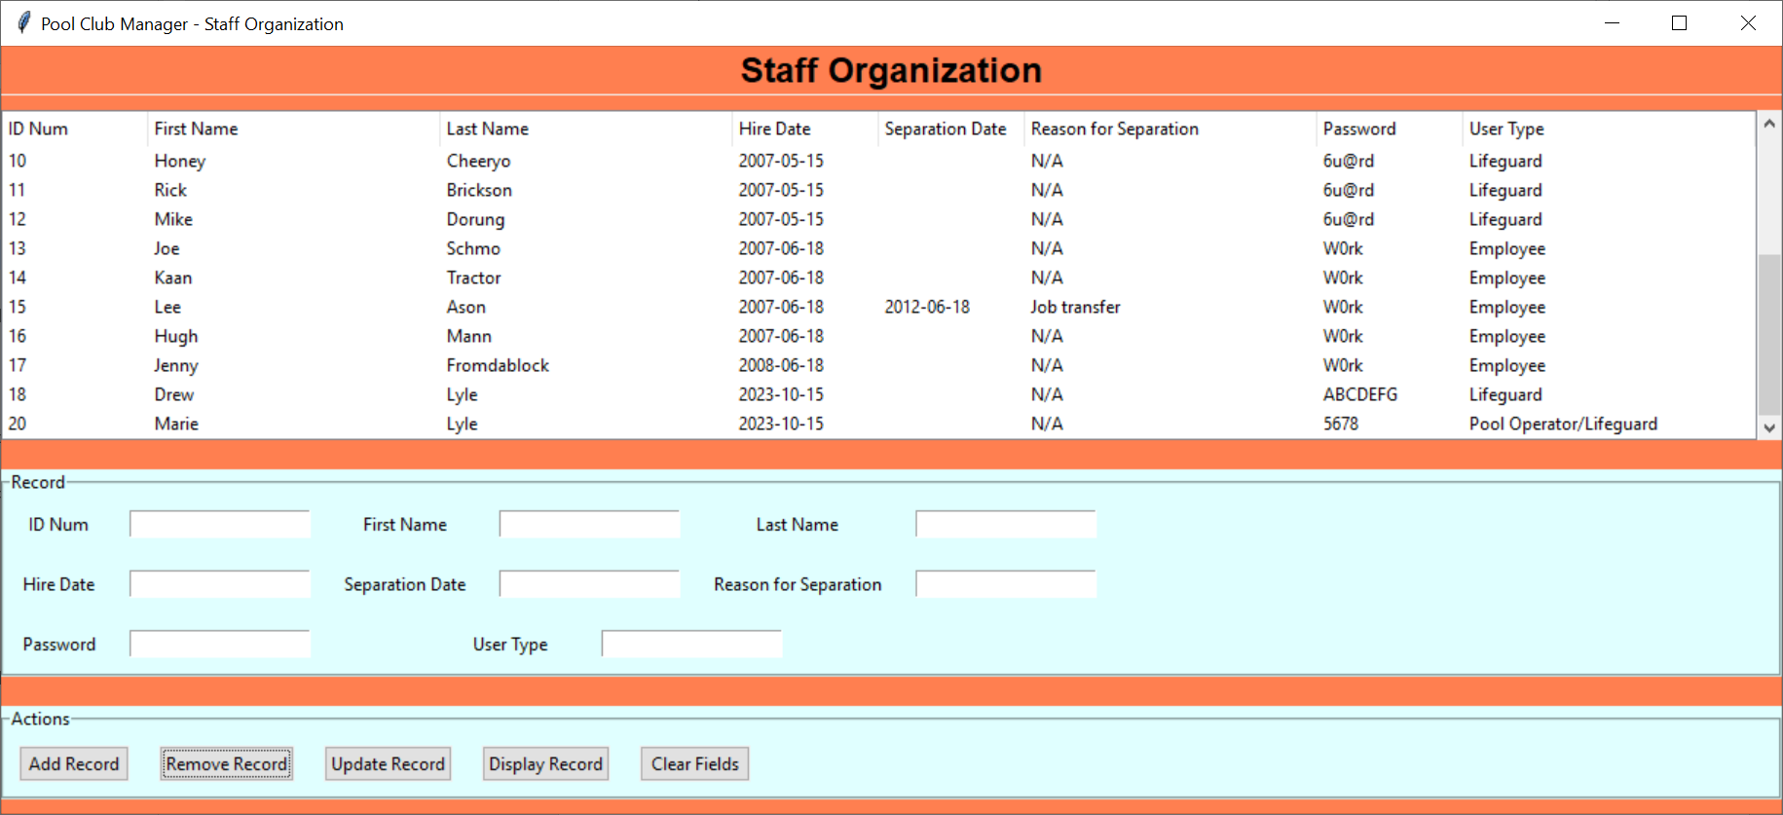

Figure 10 – The treeview of the staff table after removing a record.

The second method is similar to the first method, but has a different first step:

1. Enter the ID Num of the staff member you wish to delete from the database.
2. Click the **Remove Record** button under the Actions section of the GUI.

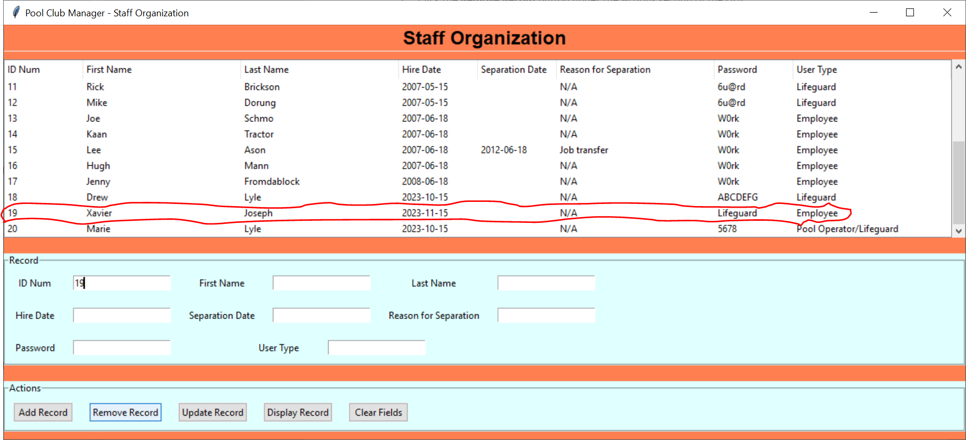

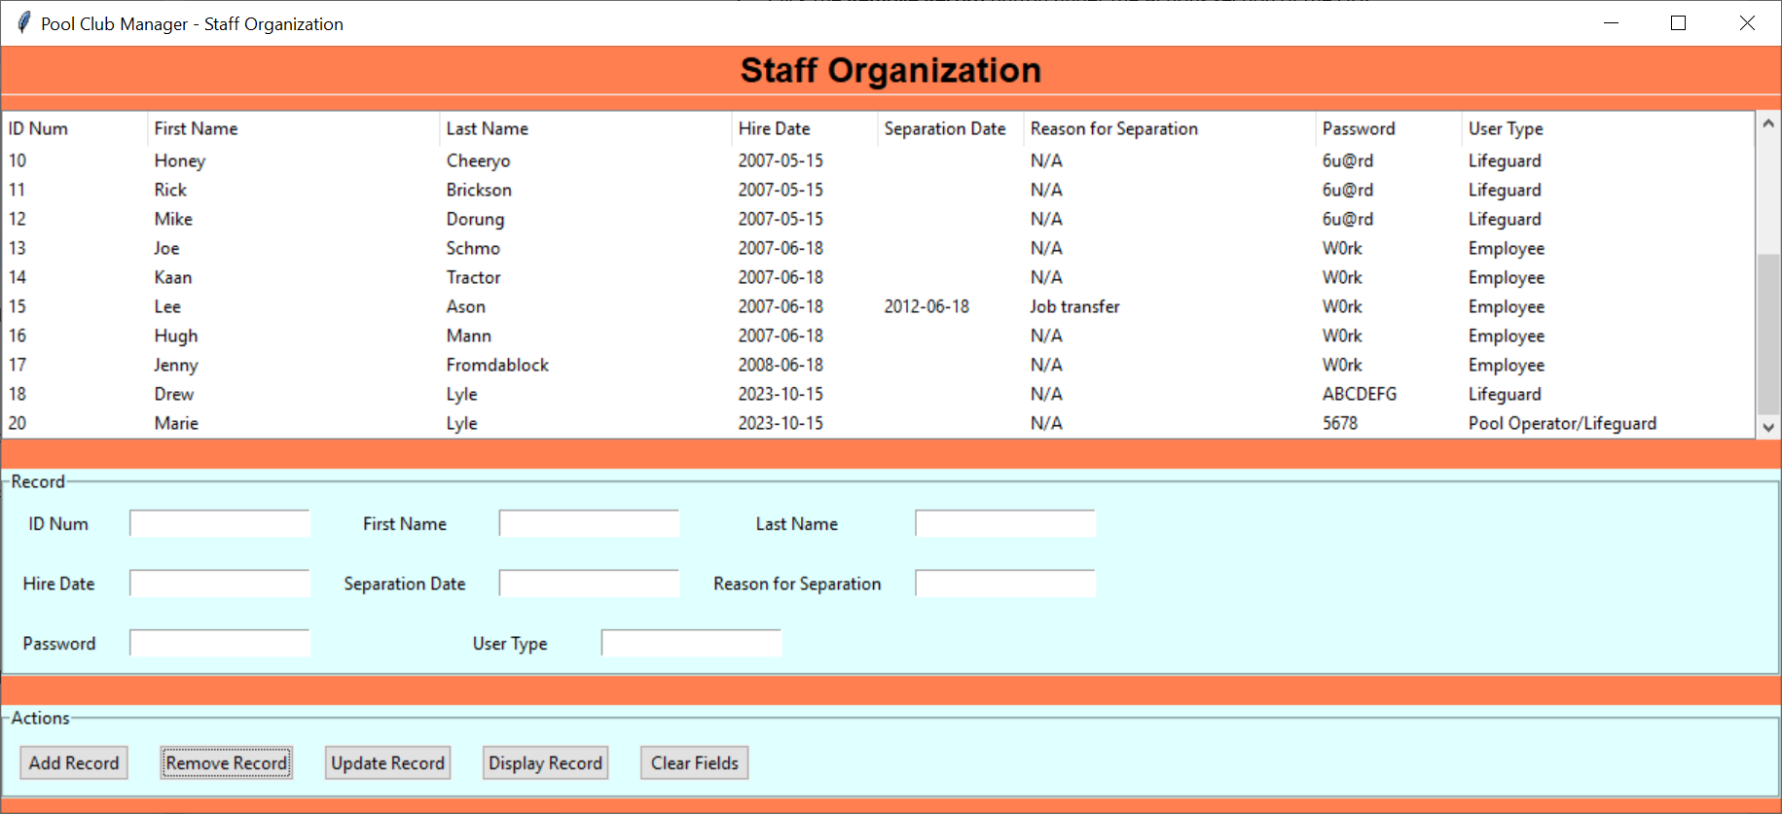

Figure 11 – A visualization of the second method to remove a record and the results.

The staff member’s record should now be gone from the database!

## Updating a Staff Member Record

First, select the record from the treeview of the staff member you wish to update. This should fill up the fields in the Records section of the GUI with the appropriate corresponding values.

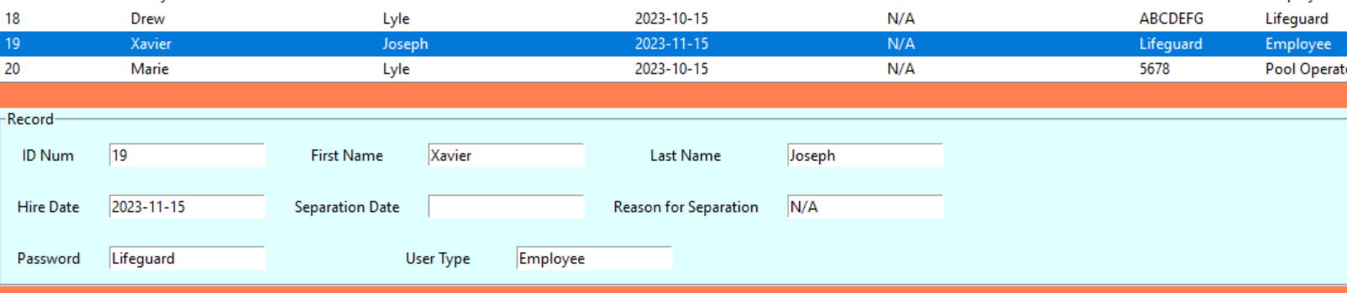

Figure 12 – Selecting a record and the values being filled in the Record fields.

Next, you want to modify one or more of the fields in the Records portion of the GUI *except* for the ID Num field. This is because the program is designed to grab in the fields from the GUI and modify the values of the record whose ID Num matches the record in the database, thus you may accidently overwrite a record of a staff member you didn’t intend to modify.

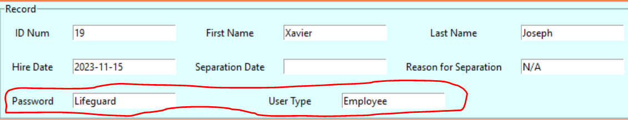

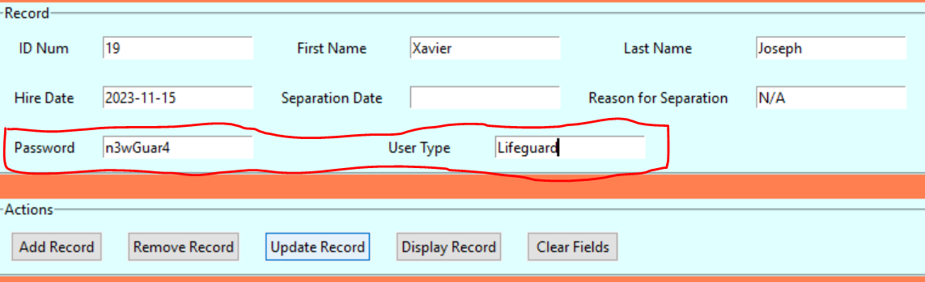

Figure 13 – Updating the record of a staff member, before and after the change.

Finally, click the Update Record button. The end result should be an updated version of your record from your database being displayed on the treeview.

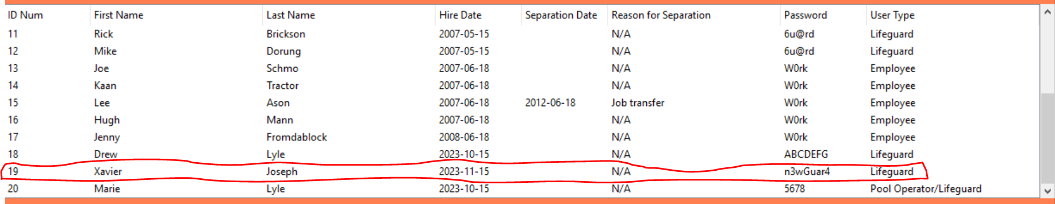

Figure 14 – The updated staff member record, circled for clarity.

## Clearing the Staff Member Entry Fields

When the fields in the Records section of the GUI have values filled in, simply click the Clear Fields button under the Actions section. They should now be blank.

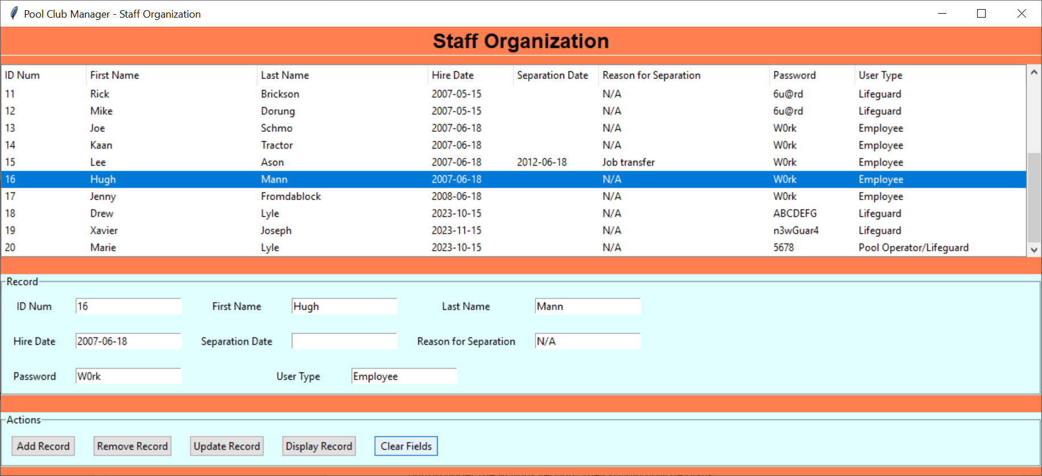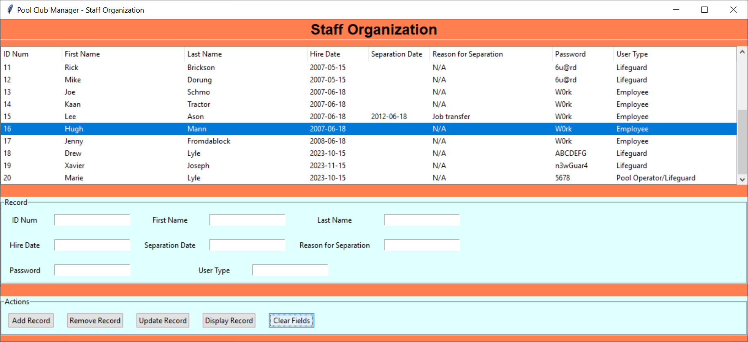

Figure 15 – Clearing the fields, before and after pressing the Clear Fields button.

# Schedule Maintenance

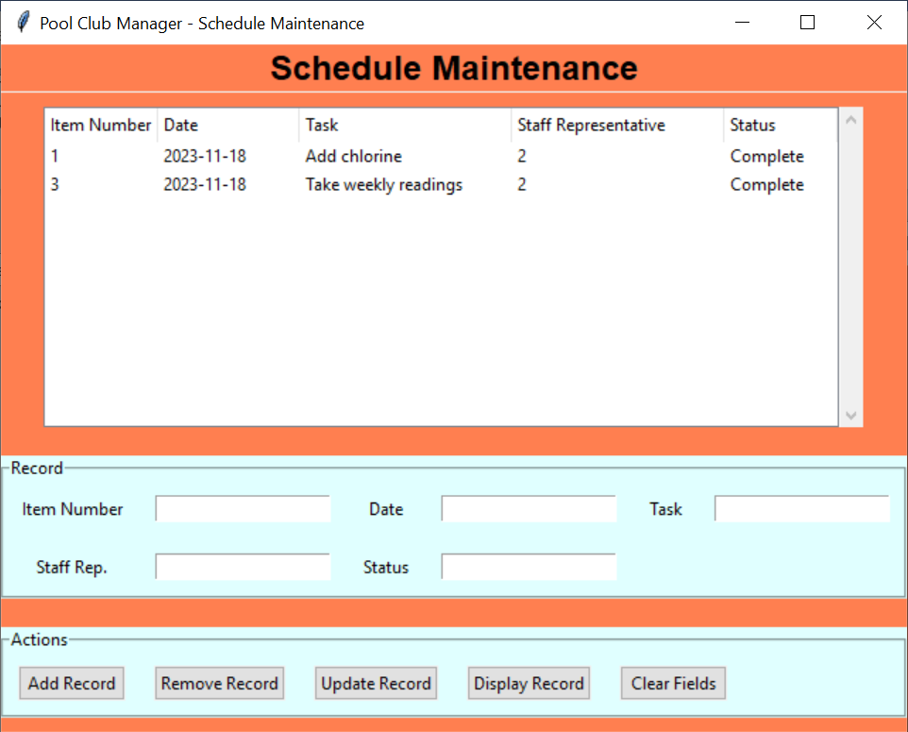

Figure – Schedule Maintenance GUI

The Schedule Maintenance GUI corresponds to the ‘maintenance’ MySQL table in the database. Figure 17 shows an example of the populated database, while Figure 18 shows the various fields that compose the table.

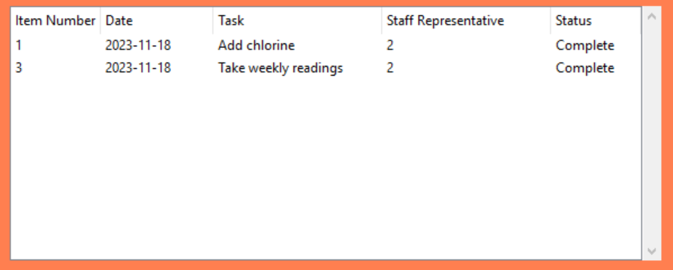

Figure – Treeview of the ‘maintenance’ table

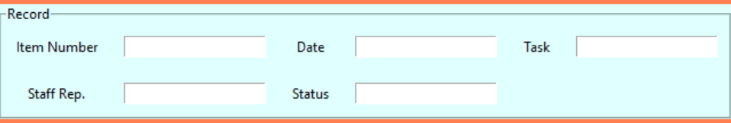

Figure – Input fields and labels

The input fields, their purpose, and their relationship to the ‘staff' table are listed in the table below.

|  |  |  |
| --- | --- | --- |
| Field | Purpose | Corresponding MySQL Variable |
| Item Number | The unique ID number for the scheduled task. | itemnumber |
| Date | The date for the task. | date |
| Task | A description of the task. | task |
| Staff Rep. | The foreign key corresponding to the ID number for the staff member overseeing the task. | staffrep |
| Status | Whether the task is completed or not. | status |

Table – Entry Fields of the Schedule Maintenance GUI

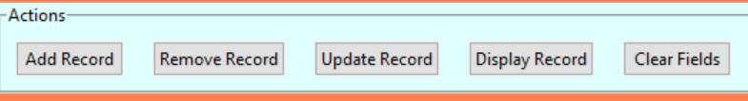

Figure – Action buttons

The following table describes the functions of each button in the Schedule Maintenance GUI in relation to the ‘schedule’ table and the program.

|  |  |  |
| --- | --- | --- |
| Button | Action | Program Equivalent |
| Add Record | Adds a record to the ‘schedule’ table of the database based on the values in the input fields. | Calls upon the addRecord() function in maintenance_gui.py, which calls upon the addMaintenanceTask() function in the maintenance_api.py file. |
| Remove Record | Removes a record from the ‘schedule’ table of the database corresponding to the value in the Item Number entry field. | Calls upon the removeRecord() function in maintenance_gui.py, which calls upon the removeMaintenanceTask() function in the maintenance_api.py file. |
| Update Record | Updates a record present in the ‘schedule’ table of the database corresponding to the value of the Item Number entry field and using data in the other entry fields to modify said record. | Calls upon the updateRecord() function in maintenance_gui.py, which calls upon the updateMaintenanceTask() function in the maintenance_api.py file. |
| Display Records | Currently activates a pop-up window with a check box labeled “Item Number.” Future iterations of this program will have said pop-up window give the user the ability to filter the treeview to only display records matching certain parameters. | Calls upon the displayRecords() function in the maintenance_gui.py file, which generates a pop-up window with a single checkbox labeled “Item Number.” |
| Clear Fields | Clears out the entry fields, leaving them all blank. | Calls upon the clear_entries() function in the maintenance_gui.py file, which clears out the entry fields. |

Table – Functions of the Actions buttons in the Schedule Maintenance GUI

## Select Treeview Record

To select a treeview record, simply click on any variable in that row and the whole thing will be highlighted. Note that this behavior also automatically fills the record fields below with data corresponding to said record. This is shown in Figure 21 below.

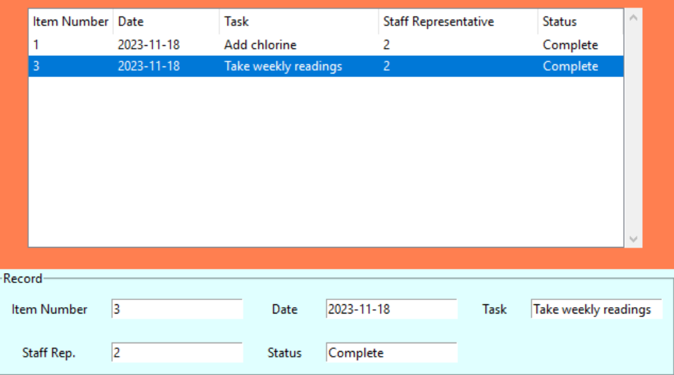

Figure – Selecting the 'Take weekly readings' record from the treeview.

## Adding a Maintenance Task Record

First, you need to fill in the fields for the record of the new maintenance task you wish to add to the database located under the Record section of the GUI. Remember to make the Item Number field a unique value. Next, click on the **Add Record** button located under the Actions section of the GUI.

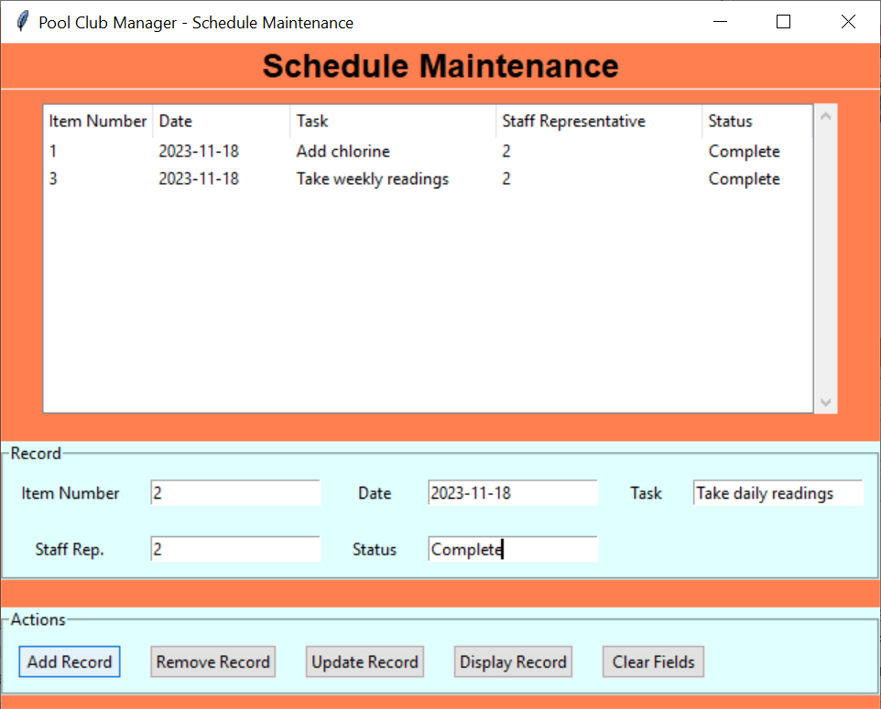

Figure 21 – Adding a task with the Item Number ‘2’ to the database.

Your new record should now be present in the GUI.

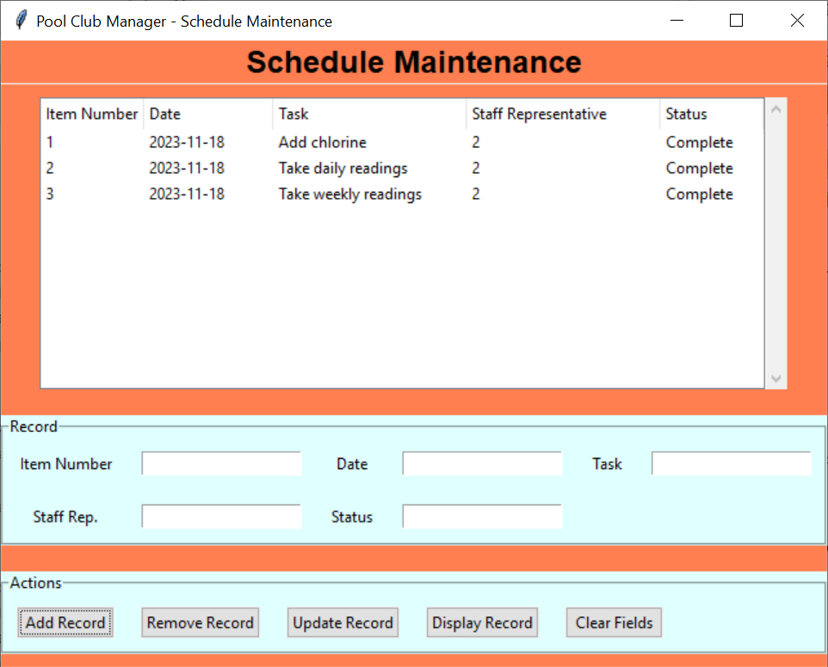

Figure 22 – The treeview of the maintenance table after adding the new task.

## Removing a Maintenance Task Record

There are two ways to go about removing a maintenance task from the database. The first method is as follows:

1. Select the row in the treeview of the maintenance task you wish to delete.
2. Click the **Remove Record** button under the Actions section of the GUI.

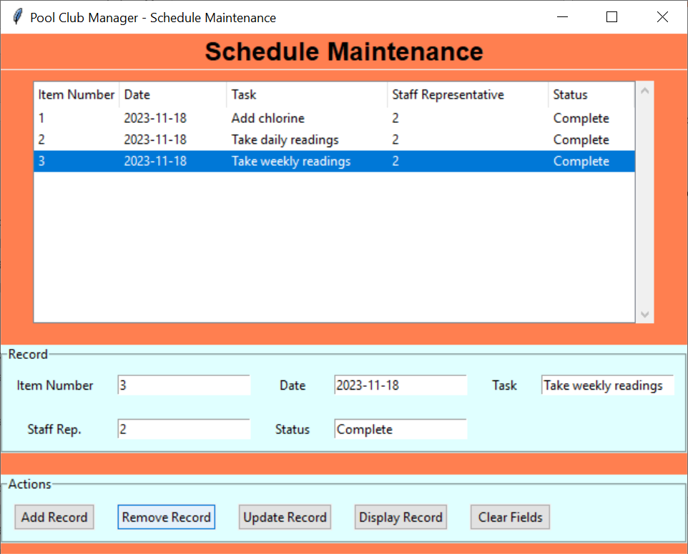

Figure 23 – A visualization of the first method to remove a record.

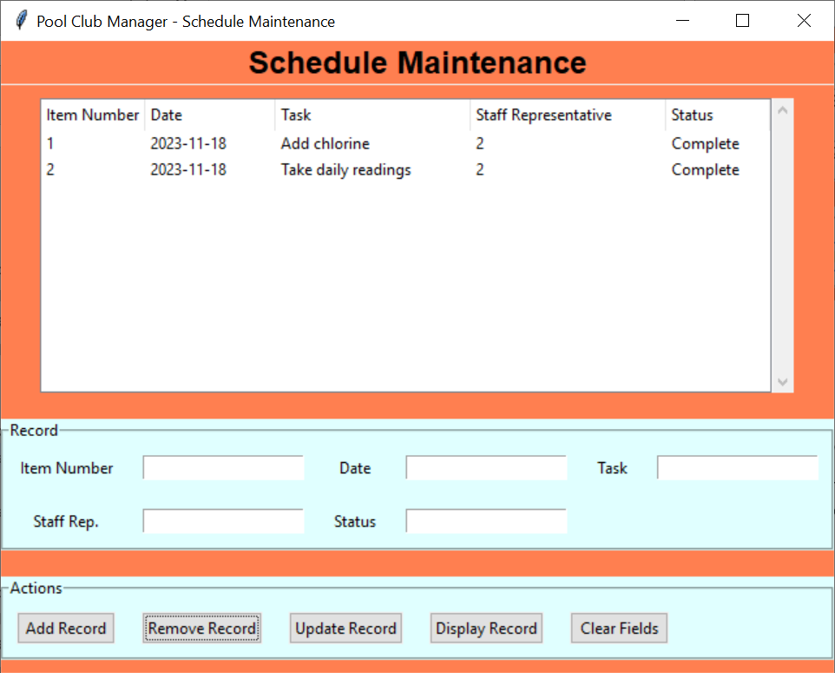

Figure 24 – The treeview of the maintenance table after removing a record.

The second method is similar to the first method, but has a different first step:

1. Enter the Item Number of the maintenance task you wish to delete from the database.
2. Click the **Remove Record** button under the Actions section of the GUI.

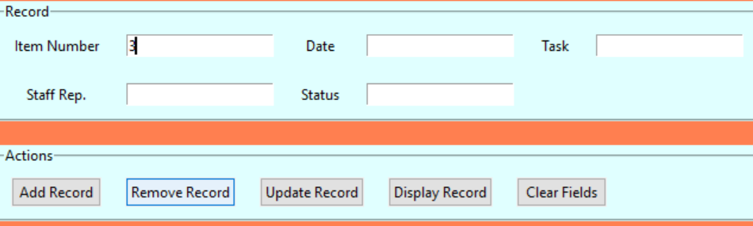

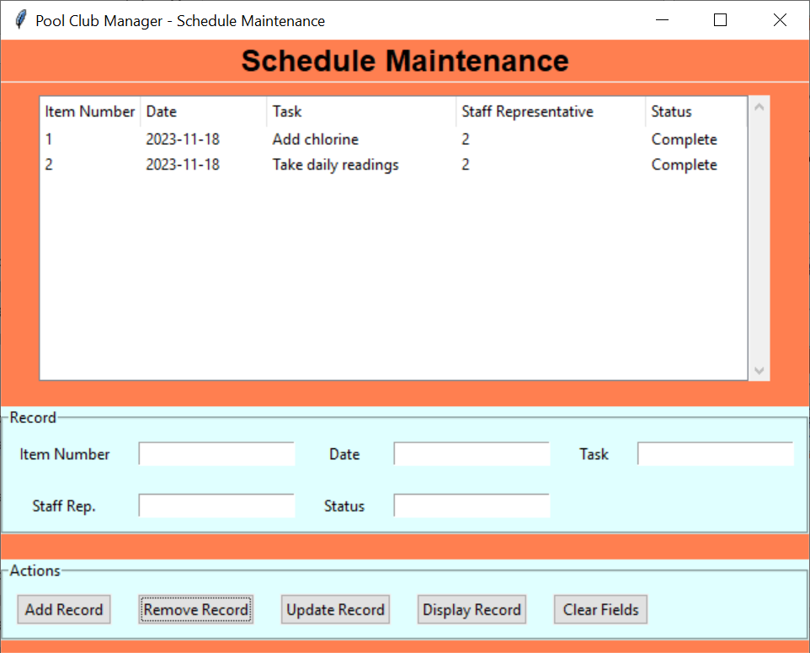

Figure 25 – A visualization of the second method to remove a record and the results.

The maintenance task’s record should now be gone from the database!

## Updating a Maintenance Task Record

First, select the record from the treeview of the maintenance task you wish to update. This should fill up the fields in the Records section of the GUI with the appropriate corresponding values.

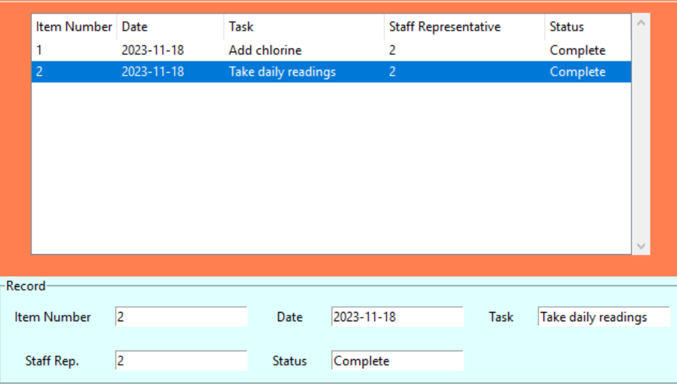

Figure 26 – Selecting a record and the values being filled in the Record fields.

Next, you want to modify one or more of the fields in the Records portion of the GUI *except* for the Item Number field. This is because the program is designed to grab in the fields from the GUI and modify the values of the record whose Item Number matches the record in the database, thus you may accidently overwrite a record of a maintenance task you didn’t intend to modify.

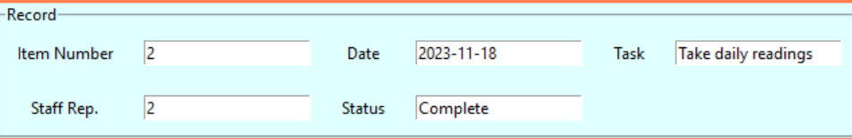

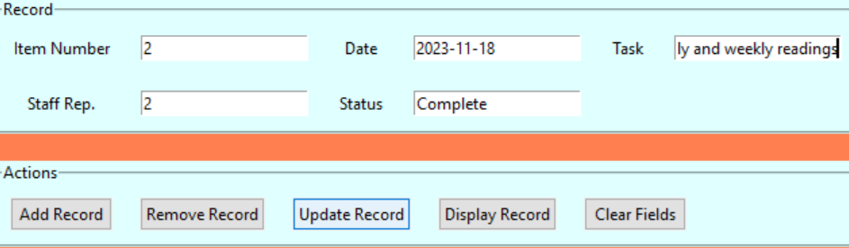

Figure 27 – Updating the record of a task, before and after the change.

Finally, click the Update Record button. The end result should be an updated version of your record from your database being displayed on the treeview.

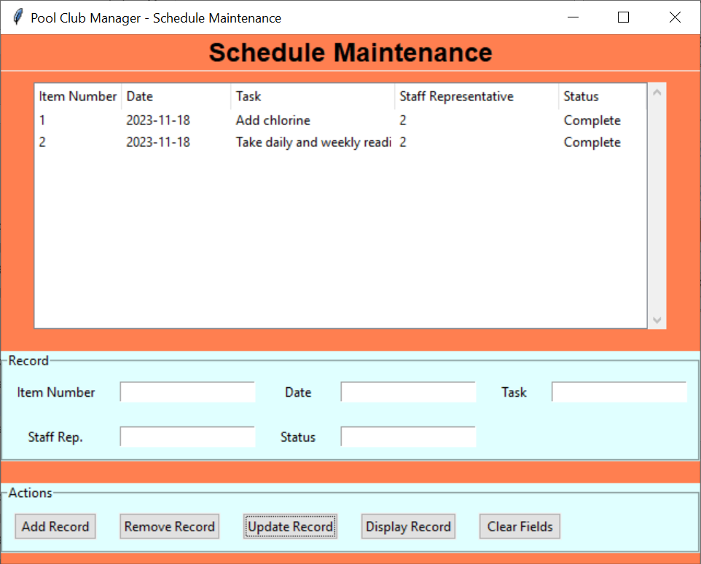

Figure 28 – The updated maintenance task record.

## Clearing the Maintenance Task Entry Fields

When the fields in the Records section of the GUI have values filled in, simply click the Clear Fields button under the Actions section. They should now be blank.

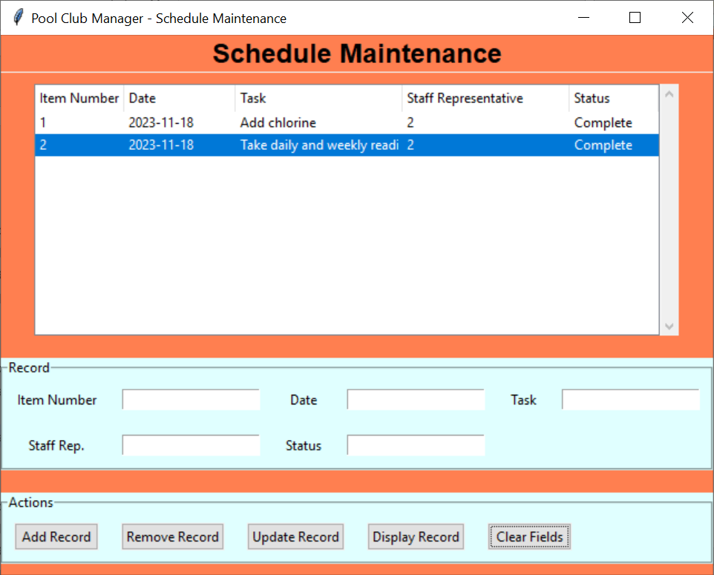

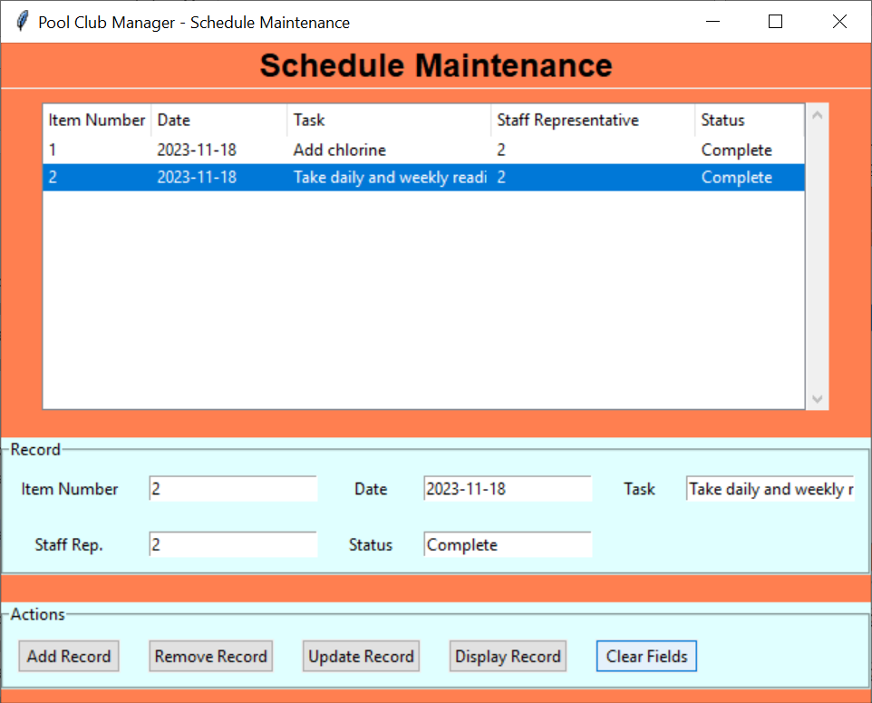

Figure 29 – Clearing the fields, before and after pressing the Clear Fields button.

# Daily Readings

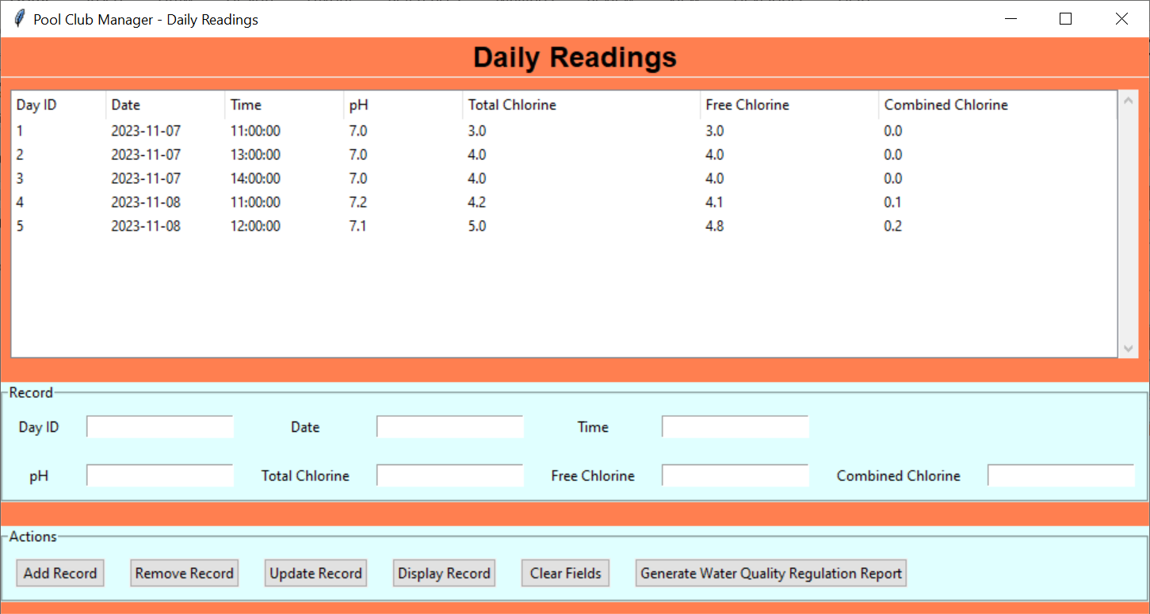

Figure – Daily Readings GUI

The Daily Readings GUI corresponds to the ‘daily_readings’ MySQL table in the database. Figure 31 shows an example of the populated database, while Figure 32 shows the various fields that compose the table.

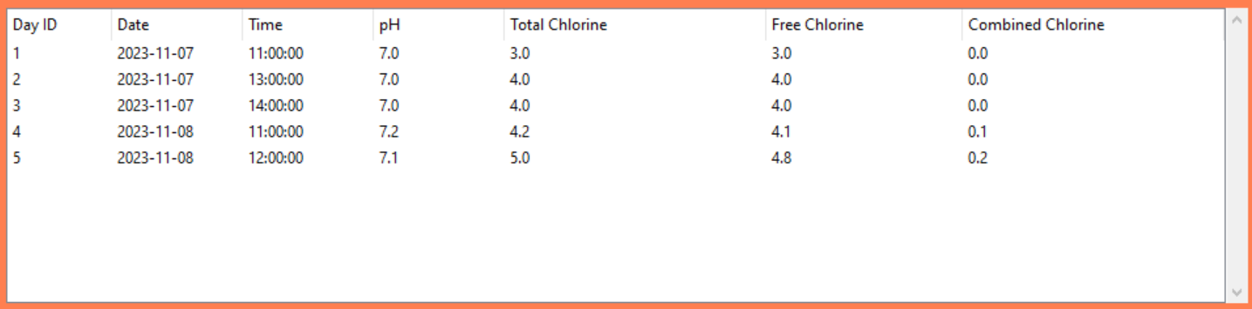

Figure – Treeview of 'daily_readings' table

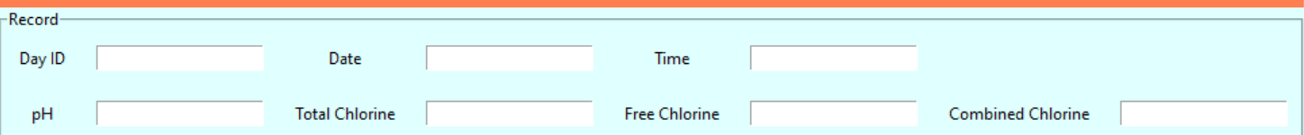

Figure – Input fields and labels

The input fields, their purpose, and their relationship to the ‘daily_readings' table are listed in the table below.

|  |  |  |
| --- | --- | --- |
| Field | Purpose | Corresponding MySQL Variable |
| Day ID | The unique ID value for a daily reading. | day_id |
| Date | The date the daily readings was taken. | date |
| Time | The time at which the daily reading was taken. | time |
| pH | The pH reading of the pool water measured in parts per million (ppm). | ph |
| Total Chlorine | The total chlorine reading of the pool water measured in parts per million (ppm). | totalchlorine |
| Free Chlorine | The free chlorine reading of the pool water measured in parts per million (ppm). | freechlorine |
| Combined Chlorine | The combined chlorine reading of the pool water measured in parts per million (ppm). It is calculated by subtracting the free chlorine value by the total chlorine value. | combinedchlorine |

Table – Entry Fields of the Daily Readings GUI.



Figure – Action buttons

The following table describes the functions of each button in the Staff Organization GUI in relation to the ‘daily_readings’ table and the program.

|  |  |  |
| --- | --- | --- |
| Button | Action | Program Equivalent |
| Add Record | Adds a record to the ‘daily_readings’ table of the database based on the values in the input fields. | Calls upon the addRecord() function in day_read_gui.py, which calls upon the addDailyReading() function in the day_read_api.py file. |
| Remove Record | Removes a record from the ‘daily_readings’ table of the database corresponding to the value in the Day ID entry field. | Calls upon the removeRecord() function in day_read_gui.py, which calls upon the removeDailyReading() function in the day_read_api.py file. |
| Update Record | Updates a record present in the ‘daily_readings’ table of the database corresponding to the value of the Day ID entry field and using data in the other entry fields to modify said record. | Calls upon the updateRecord() function in day_read_gui.py, which calls upon the updateDailyReading() function in the day_read_api.py file. |
| Display Records | Currently activates a pop-up window with a check box labeled “Day ID.” Future iterations of this program will have said pop-up window give the user the ability to filter the treeview to only display records matching certain parameters. | Calls upon the displayRecords() function in the day_read_gui.py file, which generates a pop-up window with a single checkbox labeled “Day ID.” |
| Clear Fields | Clears out the entry fields, leaving them all blank. | Calls upon the clear_entries() function in the day_read_gui.py file, which clears out the entry fields. |
| Generate Water Quality Regulation Report | Creates a PDF file from the ‘daily_readings’ table using the value in the “Date.” | Calls upon the waterQualRegReport() function in the day_read_gui.py file to pass into the generateDailyReport() function of the daily_report.py file. |

Table – Functions of the Actions buttons in Daily Readings.

## Select Treeview Record

To select a treeview record, simply click on any variable in that row and the whole thing will be highlighted. Note that this behavior also automatically fills the record fields below with data corresponding to said record. This is shown in Figure 34 below.

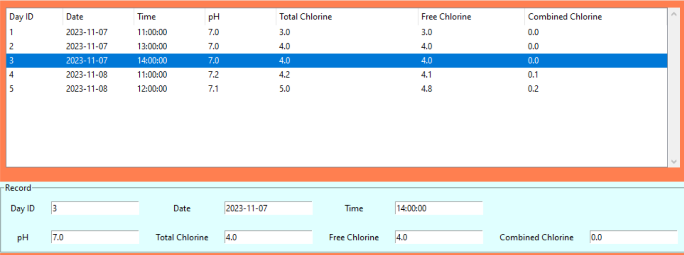

Figure – Selecting the record with a Day ID value of '3' from the treeview.

## Adding a Daily Reading Record

First, you need to fill in the fields for the record of the new daily reading you wish to add to the database located under the Record section of the GUI. Remember to make the Day ID field a unique value. Next, click on the **Add Record** button located under the Actions section of the GUI.

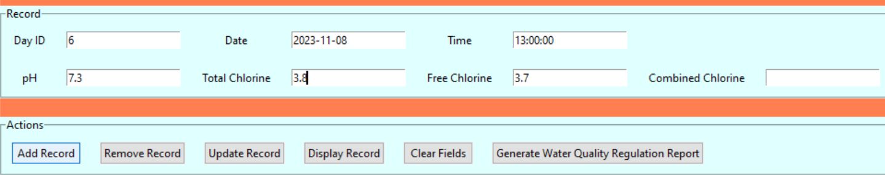

Figure 35 – Adding a daily reading with the Day ID ‘6’ to the database.

Your new record should now be present in the GUI.

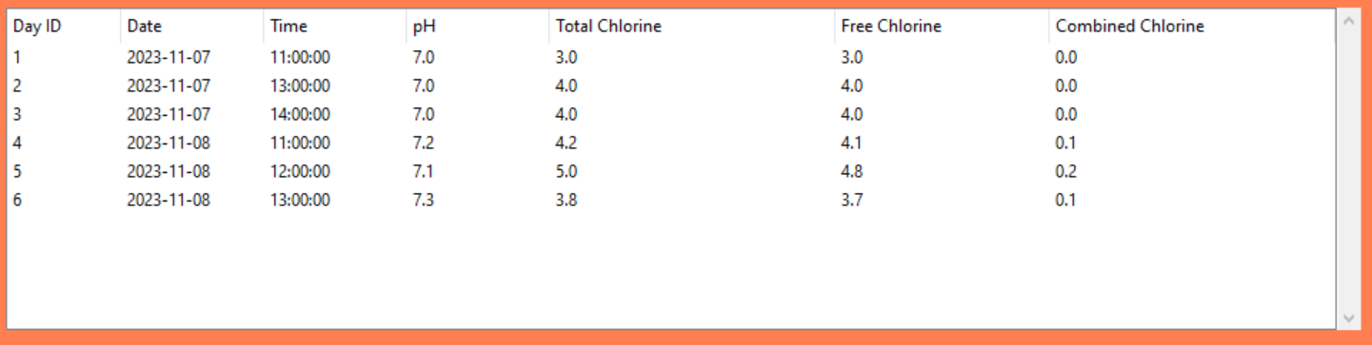

Figure 36 – The treeview of the daily_readings table after adding the new daily reading.

## Removing a Daily Reading Record

There are two ways to go about removing a daily reading from the database. The first method is as follows:

1. Select the row in the treeview of the daily reading you wish to delete.
2. Click the **Remove Record** button under the Actions section of the GUI.

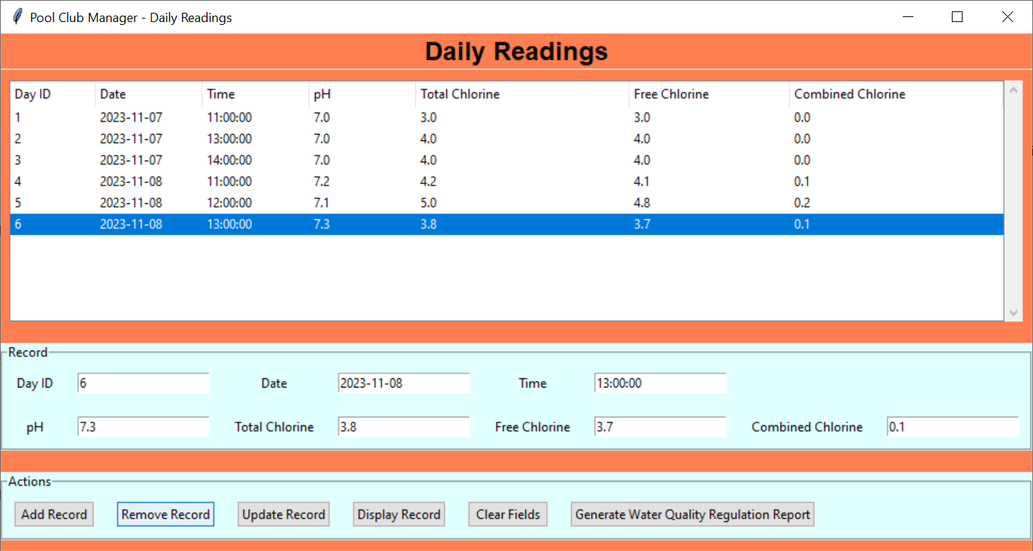

Figure 37 – A visualization of the first method to remove a record.

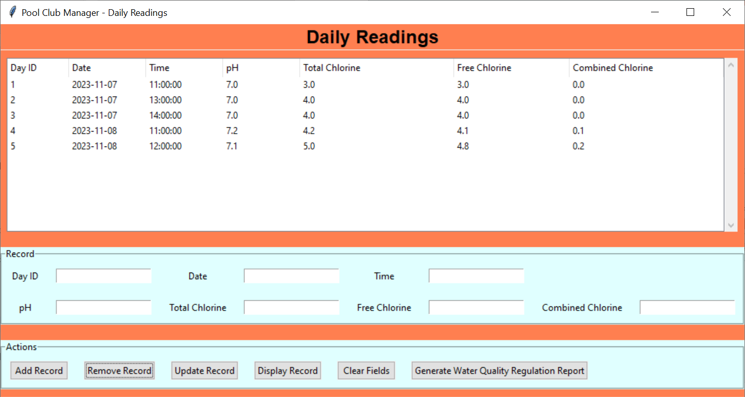

Figure 38 – The treeview of the daily_readings table after removing a record.

The second method is similar to the first method, but has a different first step:

1. Enter the Day ID of the daily reading you wish to delete from the database.
2. Click the **Remove Record** button under the Actions section of the GUI.

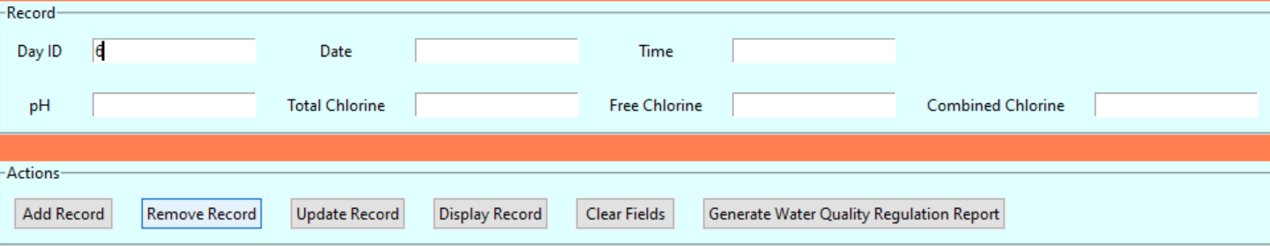

Figure 39 – A visualization of the second method to remove a record and the results.

The daily reading’s record should now be gone from the database!

## Updating a Daily Reading Record

First, select the record from the treeview of the daily reading you wish to update. This should fill up the fields in the Records section of the GUI with the appropriate corresponding values.

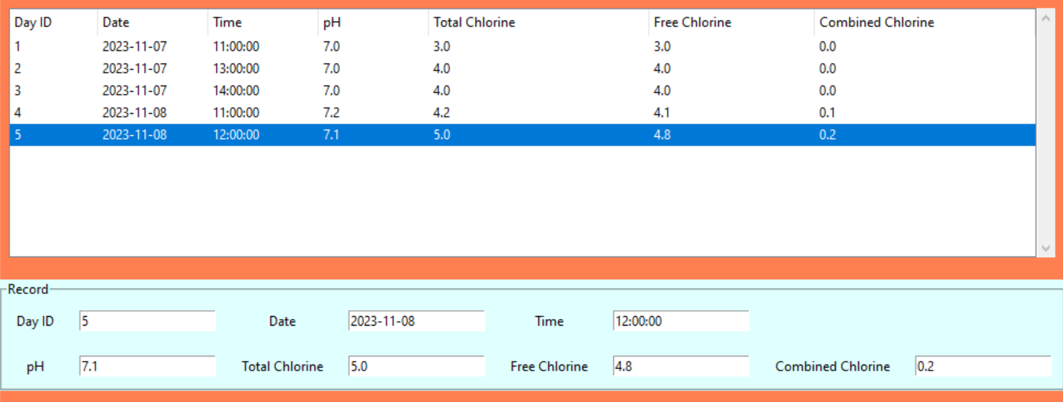

Figure 40 – Selecting a record and the values being filled in the Record fields.

Next, you want to modify one or more of the fields in the Records portion of the GUI *except* for the Day ID field. This is because the program is designed to grab in the fields from the GUI and modify the values of the record whose Day ID matches the record in the database, thus you may accidently overwrite a record of a daily reading you didn’t intend to modify.

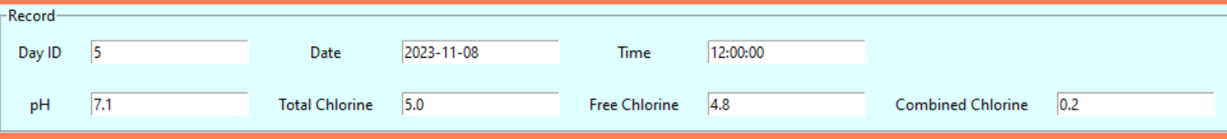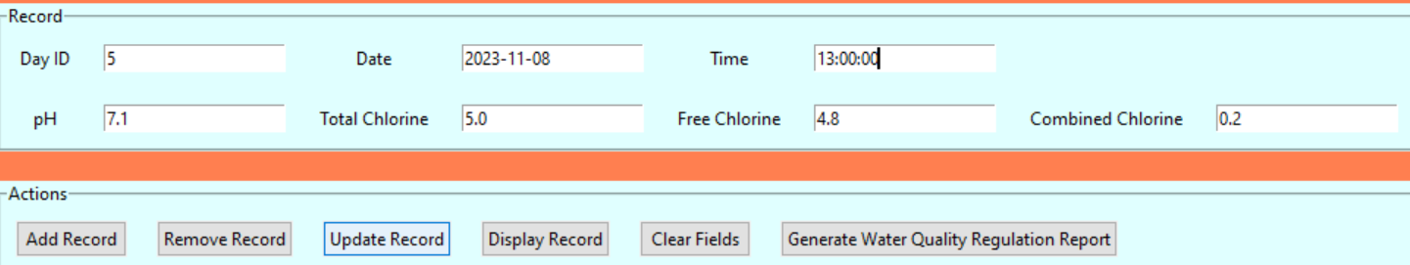

Figure 41 – Updating the record of a daily reading, before and after the change.

Finally, click the Update Record button. The end result should be an updated version of your record from your database being displayed on the treeview.

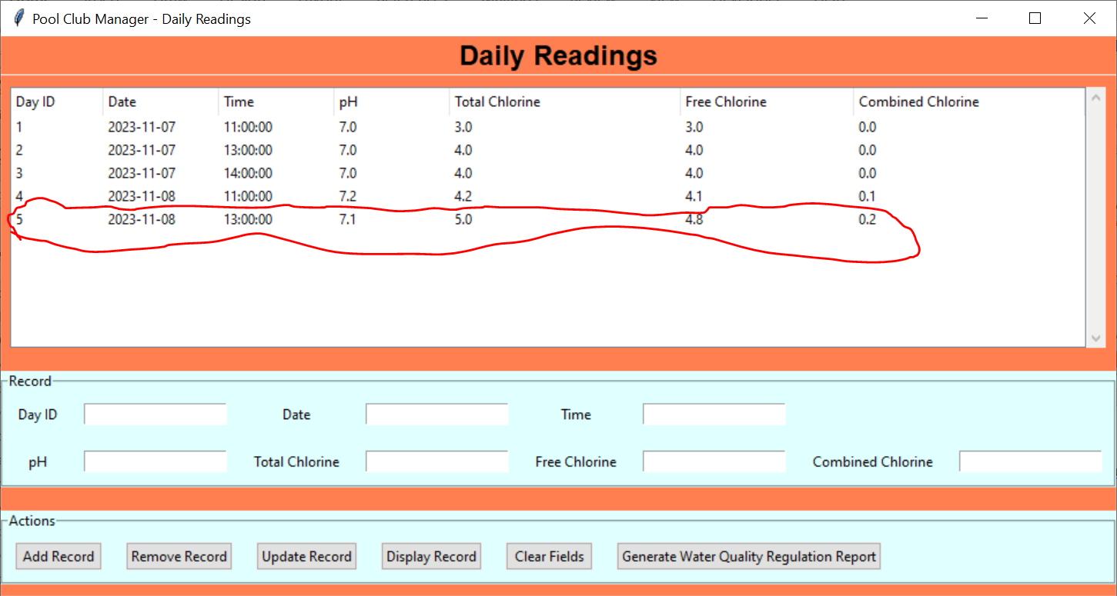

Figure 42 – The updated daily reading record.

## Clearing the Daily Reading Entry Fields

When the fields in the Records section of the GUI have values filled in, simply click the Clear Fields button under the Actions section. They should now be blank.

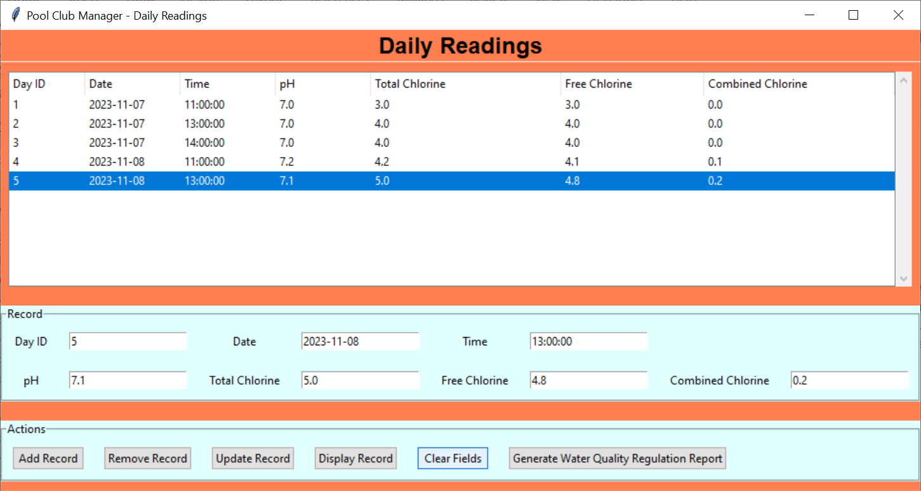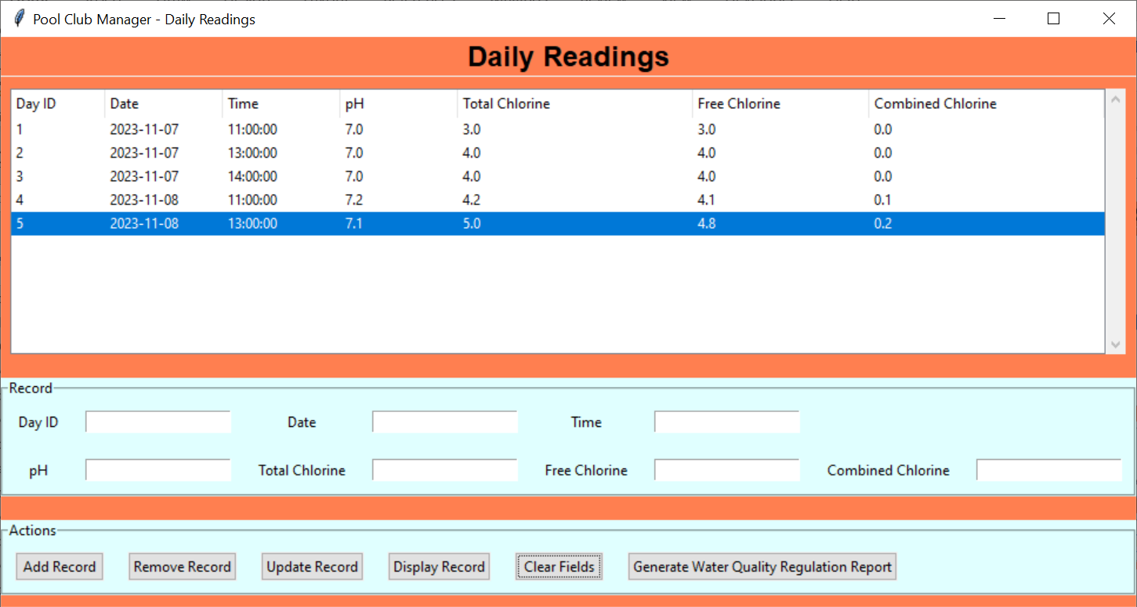

Figure 43 – Clearing the fields, before and after pressing the Clear Fields button.

## Generating a Daily Readings Water Quality Regulation Report

Compared to the other tasks, which are already pretty simple, generating a water quality regulation report of the daily readings is even simpler. All the user must do is fill in the Date field under the Record section, followed by clicking the **Generate Water Quality Regulation Report** button under the Actions section. There will then be a pop-up notifying the user that the report has been successfully generated.

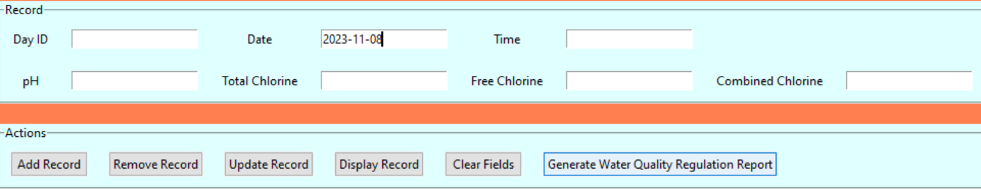

Figure 44 – Inputing the date to be used for the Daily Readings Water Quality Regulation Report.

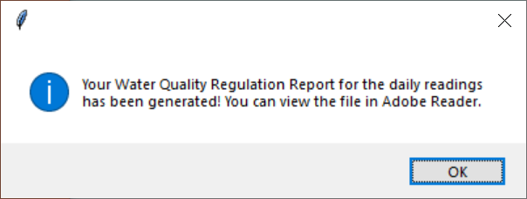

Figure 45 – Popup message informing the user that the report has been generated.

Please note that the other fields do not matter in order for the program to generate said report.

# Weekly Readings

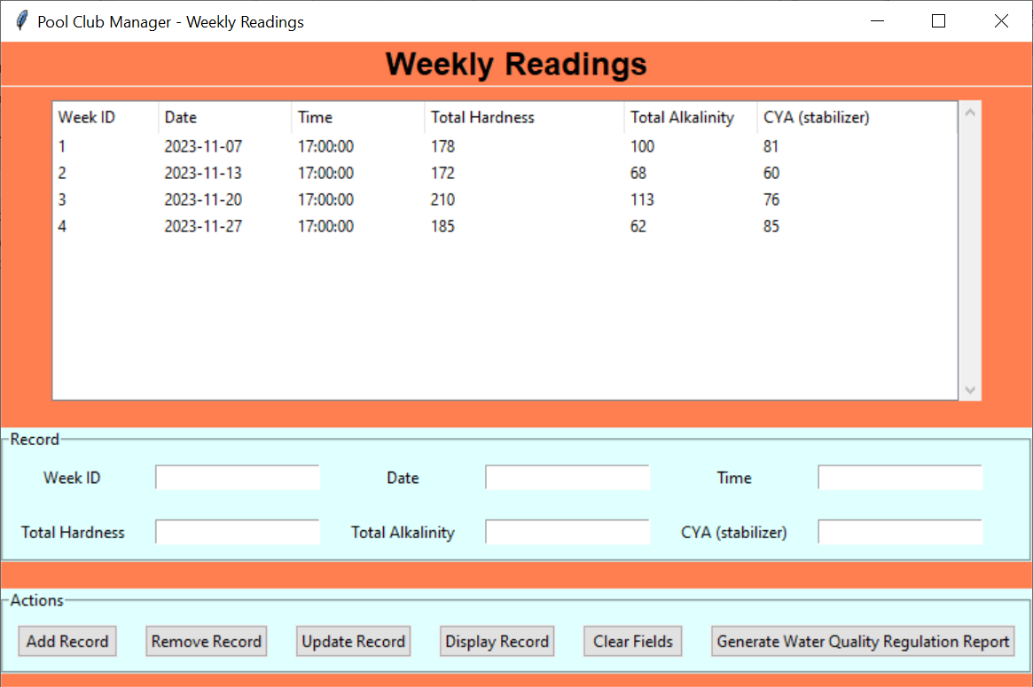

Figure – Weekly Readings GUI

The Weekly Readings GUI corresponds to the ‘weekly_readings’ MySQL table in the database. Figure 47 shows an example of the populated database, while Figure 48 shows the various fields that compose the table.

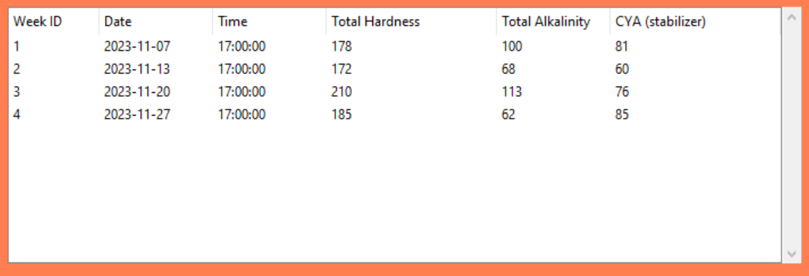

Figure – Treeview of 'weekly_readings' table

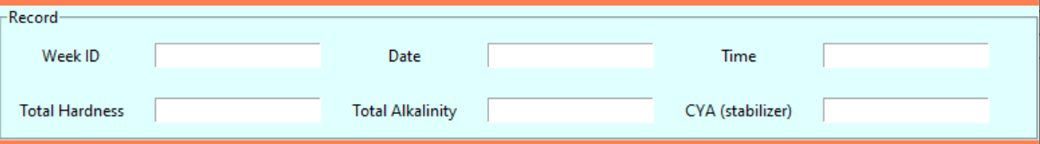

Figure – Input fields and labels



Figure – Action buttons

## Select Treeview Record

To select a treeview record, simply click on any variable in that row and the whole thing will be highlighted. Note that this behavior also automatically fills the record fields below with data corresponding to said record. This is shown in Figure 50 below.

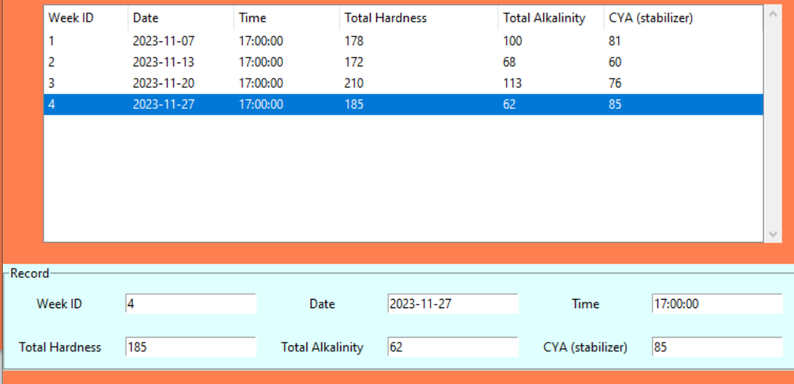

Figure – Selecting the record with the Week ID value of '4' from the treeview.

## Adding a Weekly Reading Record

First, you need to fill in the fields for the record of the new weekly reading you wish to add to the database located under the Record section of the GUI. Remember to make the Week ID field a unique value. Next, click on the **Add Record** button located under the Actions section of the GUI.

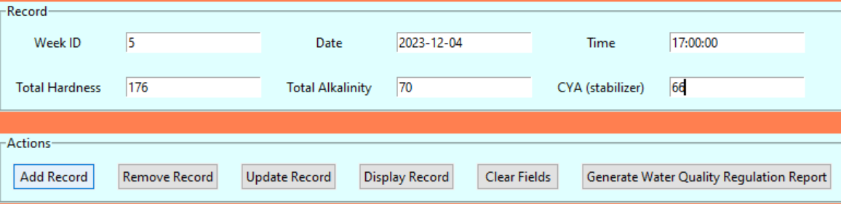

Figure 51 – Adding a weekly reading with the Week ID ‘5’ to the database.

Your new record should now be present in the GUI.

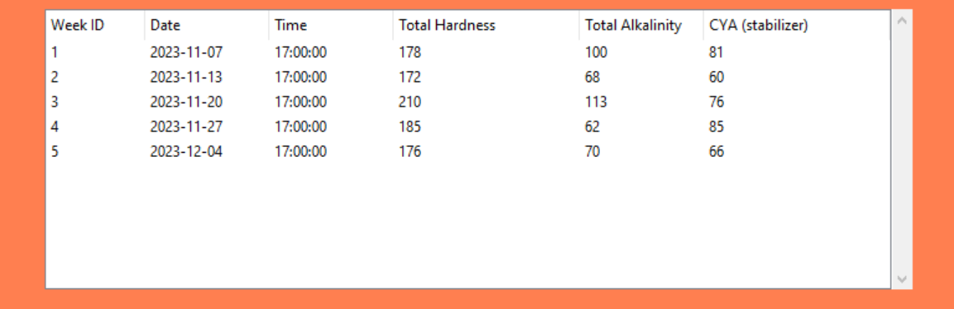

Figure 52 – The treeview of the weekly_readings table after adding the new weekly reading.

## Removing a Weekly Reading Record

There are two ways to go about removing a weekly reading from the database. The first method is as follows:

1. Select the row in the treeview of the weekly reading you wish to delete.
2. Click the **Remove Record** button under the Actions section of the GUI.

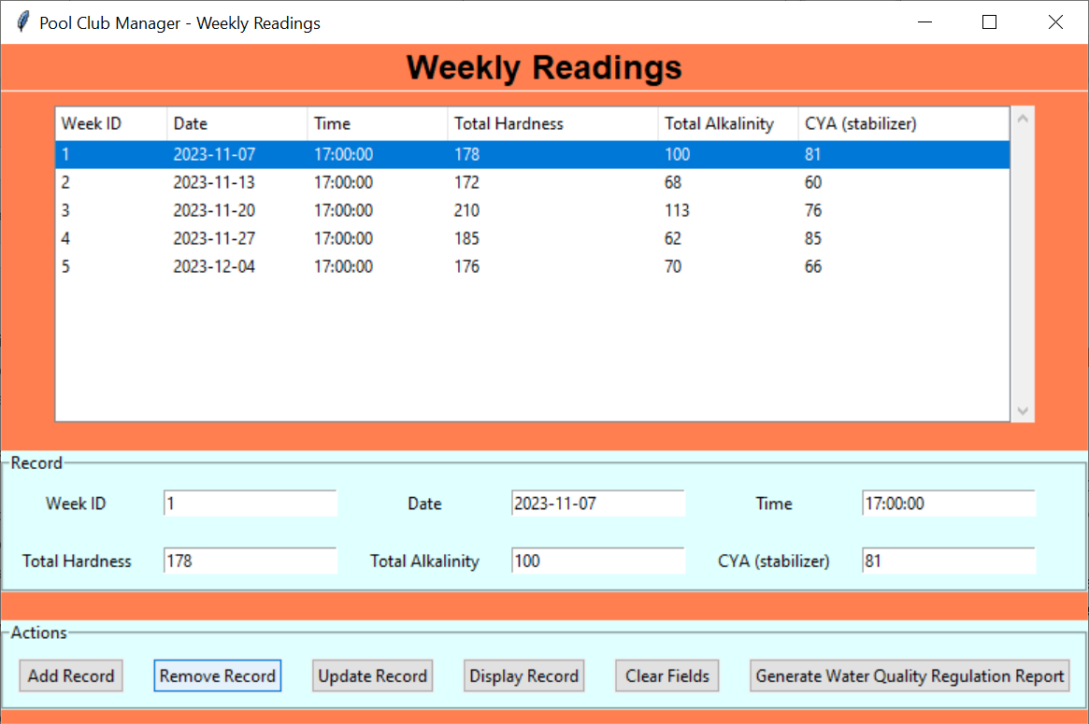

Figure 53 – A visualization of the first method to remove a record.

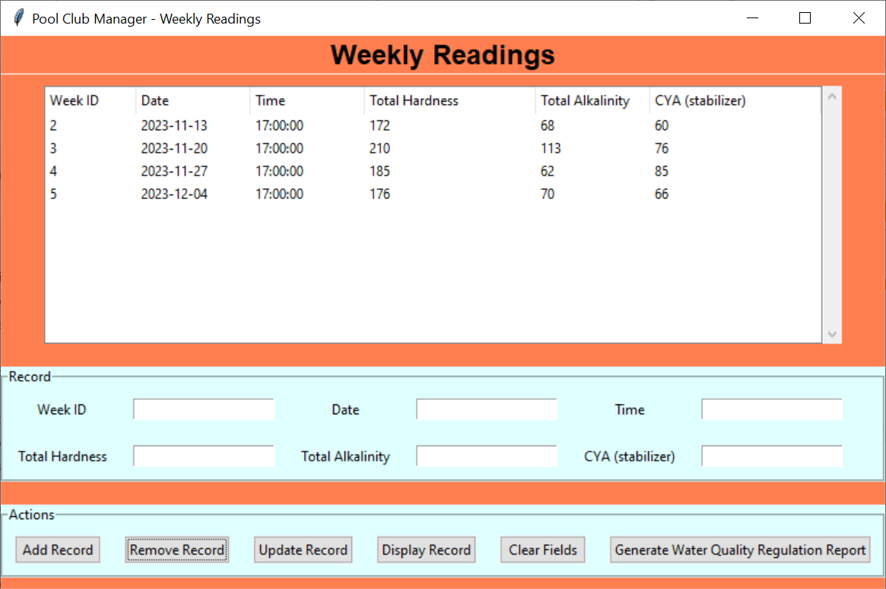

Figure 54 – The treeview of the weekly_readings table after removing a record.

The second method is similar to the first method, but has a different first step:

1. Enter the Week ID of the weekly reading you wish to delete from the database.
2. Click the **Remove Record** button under the Actions section of the GUI.

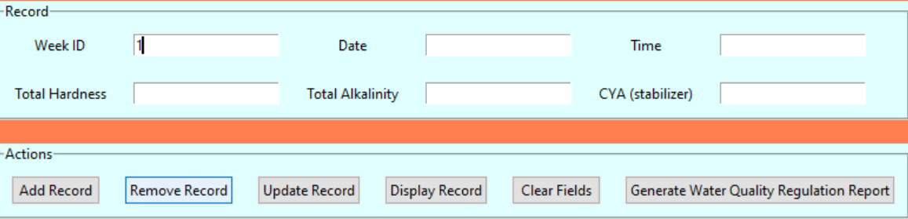



Figure 55 – A visualization of the second method to remove a record and the results.

The weekly reading’s record should now be gone from the database!

## Updating a Weekly Reading Record

First, select the record from the treeview of the weekly reading you wish to update. This should fill up the fields in the Records section of the GUI with the appropriate corresponding values.

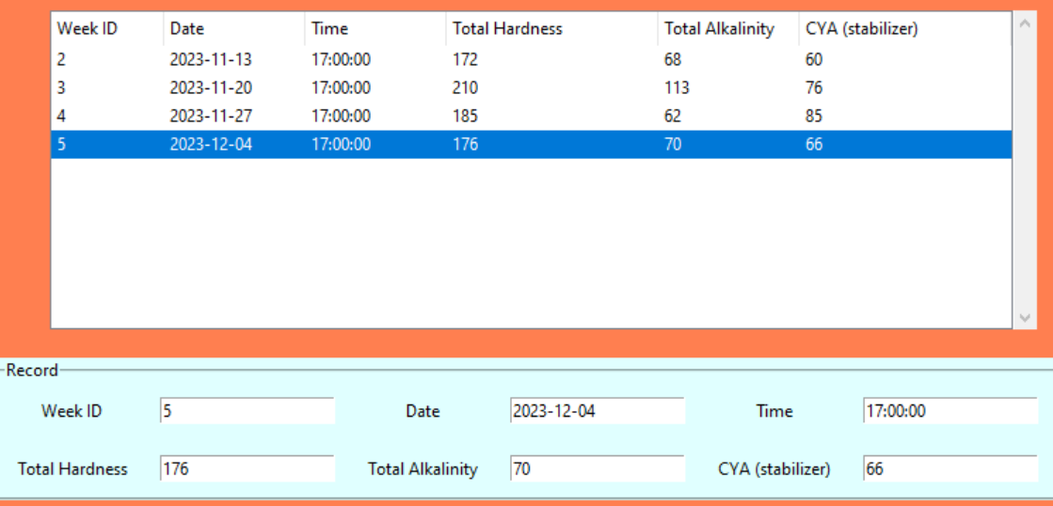

Figure 56 – Selecting a record and the values being filled in the Record fields.

Next, you want to modify one or more of the fields in the Records portion of the GUI *except* for the Week ID field. This is because the program is designed to grab in the fields from the GUI and modify the values of the record whose Week ID matches the record in the database, thus you may accidently overwrite a record of a weekly reading you didn’t intend to modify.

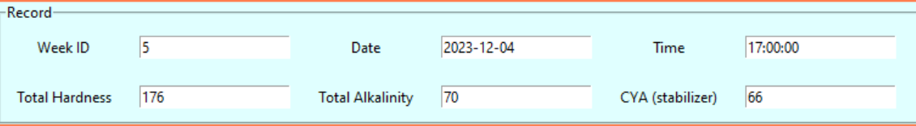

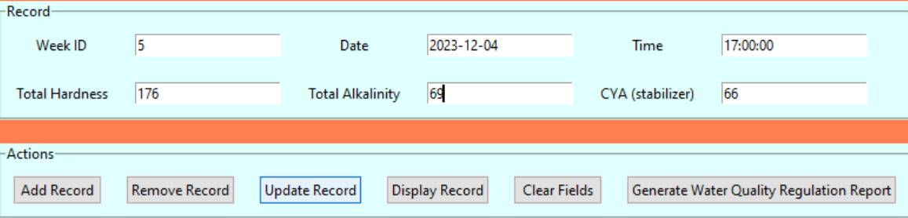

Figure 57 – Updating the record of a weekly reading, before and after the change.

Finally, click the Update Record button. The end result should be an updated version of your record from your database being displayed on the treeview.

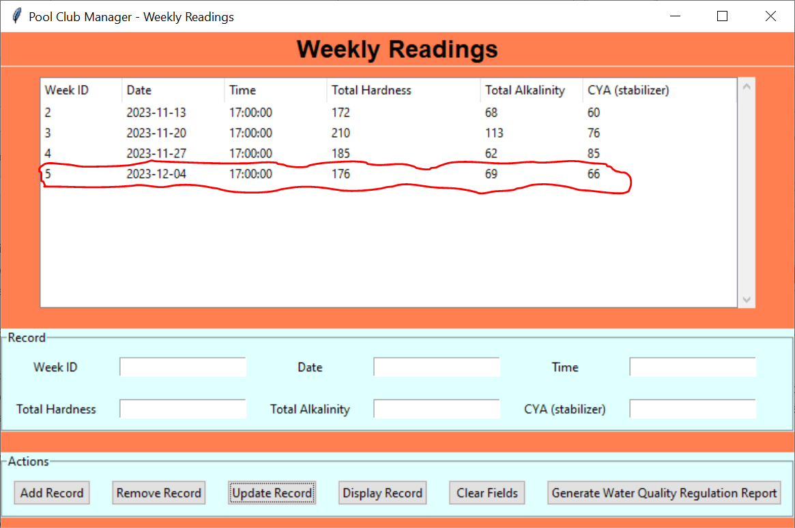

Figure 58 – The updated weekly reading record, circled for clarity.

## Clearing the Weekly Reading Entry Fields

When the fields in the Records section of the GUI have values filled in, simply click the Clear Fields button under the Actions section. They should now be blank.

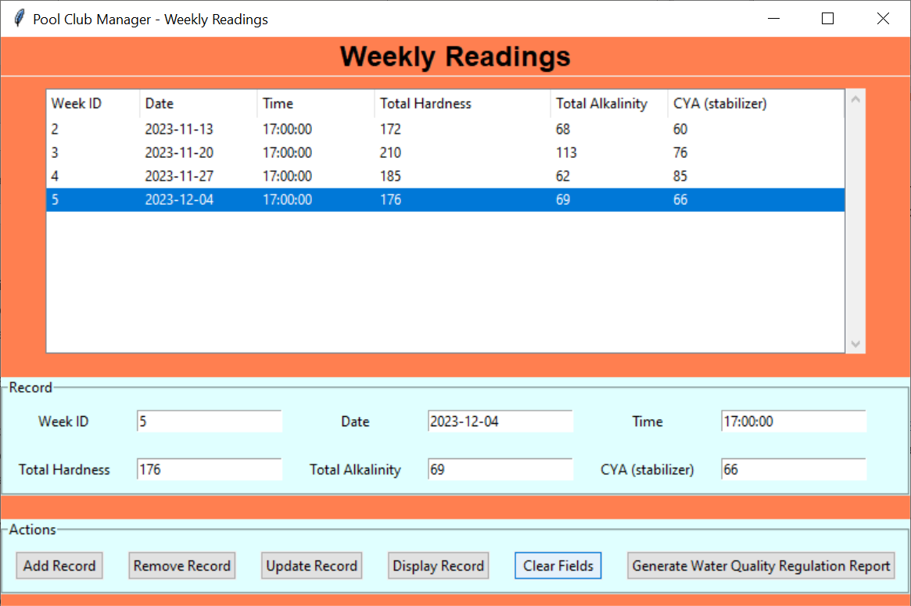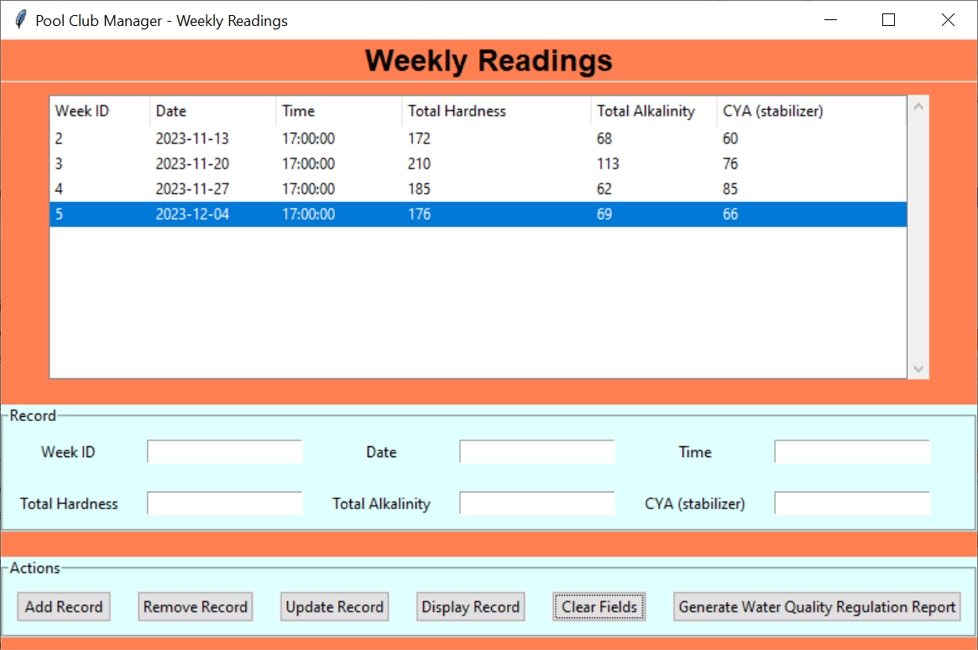

Figure 59 – Clearing the fields, before and after pressing the Clear Fields button.

## Generating a Weekly Readings Water Quality Regulation Report

Generating a water quality regulation report of the weekly readings is just as straightforward as generating one for the daily readings. Simply fill in the Date field under the Record section, followed by clicking the **Generate Water Quality Regulation Report** button under the Actions section. There will then be a pop-up notifying the user that the report has been successfully generated.

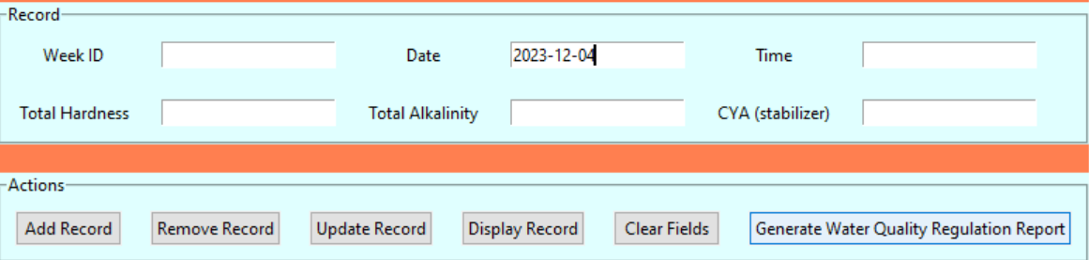

Figure 60 - Inputing the date to be used for the Weekly Readings Water Quality Regulation Report.

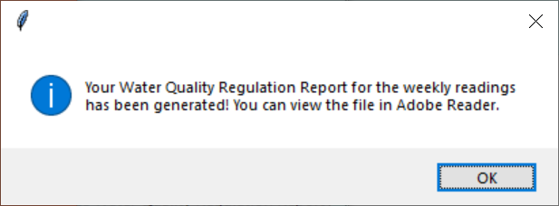

Figure 61 - Popup message informing the user that the report has been generated.

Please note that just like in the previous window, the other fields do not matter in order for the program to generate said report.

# Pool Chemical Supply

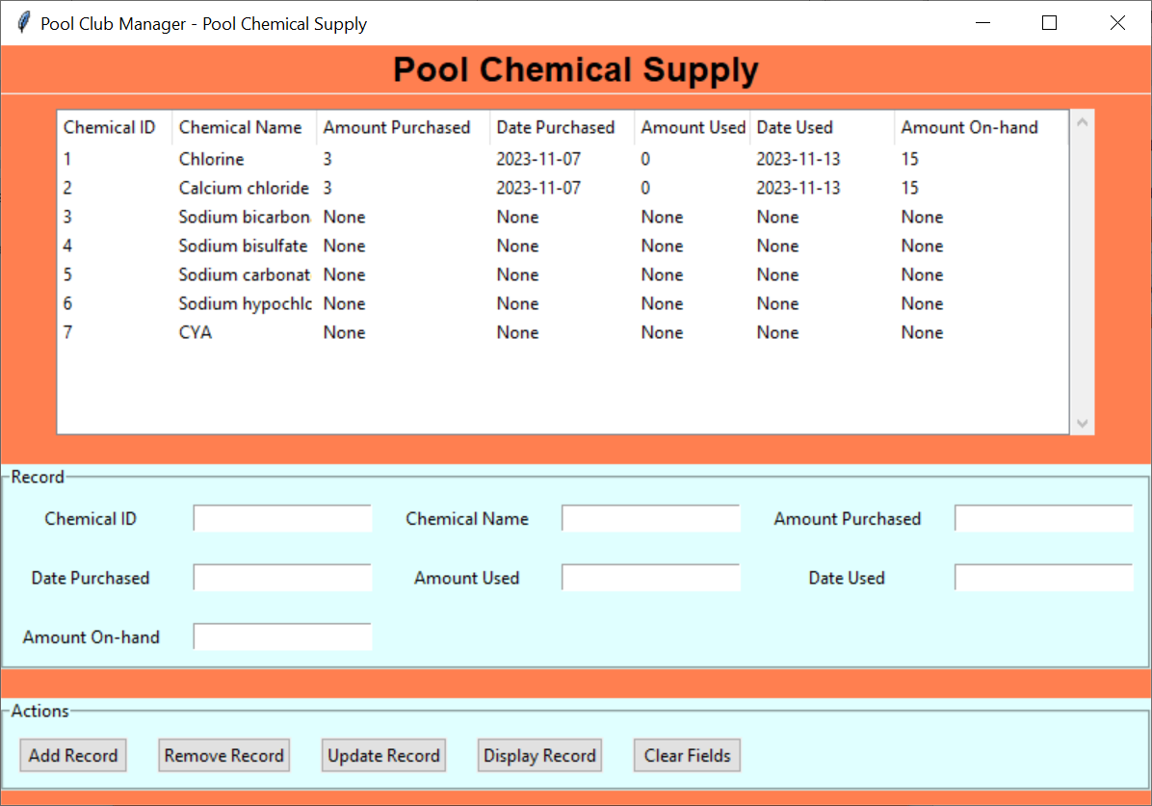

Figure – Pool Chemical Supply GUI

The Pool Chemical Supply GUI corresponds to the ‘pool_chemical_supply’ MySQL table in the database. Figure 63 shows an example of the populated database, while Figure 64 shows the various fields that compose the table.

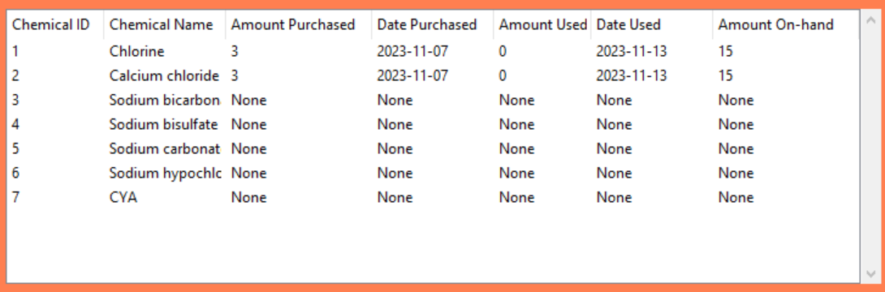

Figure – Treeview of the 'pool_chemical_supply' table

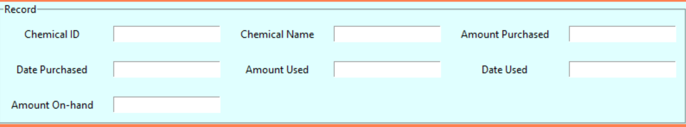

Figure – Input fields and labels

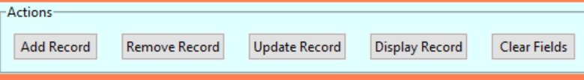

Figure – Action buttons

## Select Treeview Record

To select a treeview record, simply click on any variable in that row and the whole thing will be highlighted. Note that this behavior also automatically fills the record fields below with data corresponding to said record. This is shown in Figure 66 below.

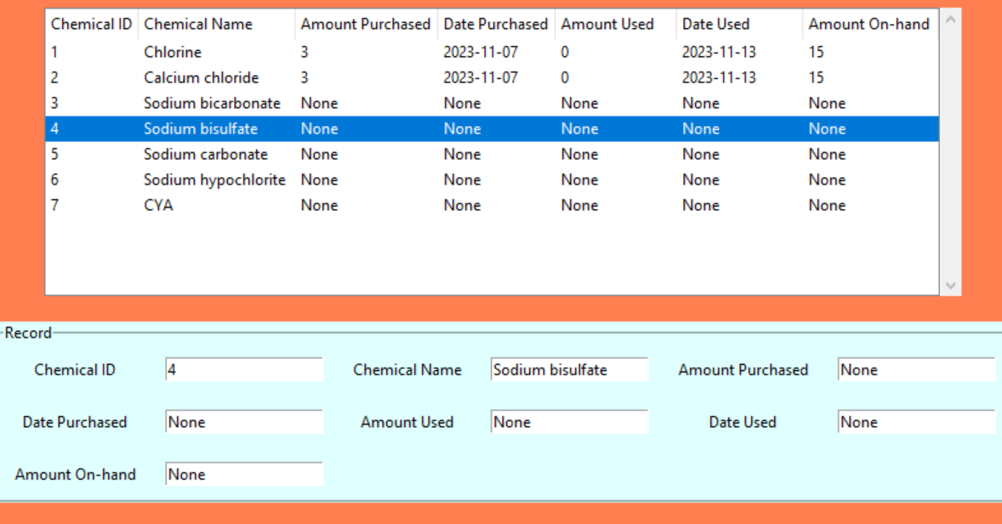

Figure – Selecting the 'Sodium bisulfate' record from the treeview.

## Adding a Pool Chemical Record

First, you need to fill in the fields for the record of the new pool chemical you wish to add to the database located under the Record section of the GUI. Remember to make the Chemical ID field a unique value. Next, click on the **Add Record** button located under the Actions section of the GUI.

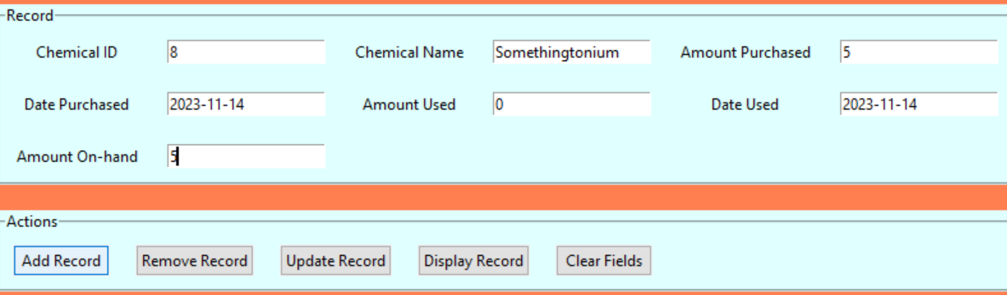

Figure 67 – Adding a new chemical with the Chemical ID ‘8’ to the database.

Your new record should now be present in the GUI.

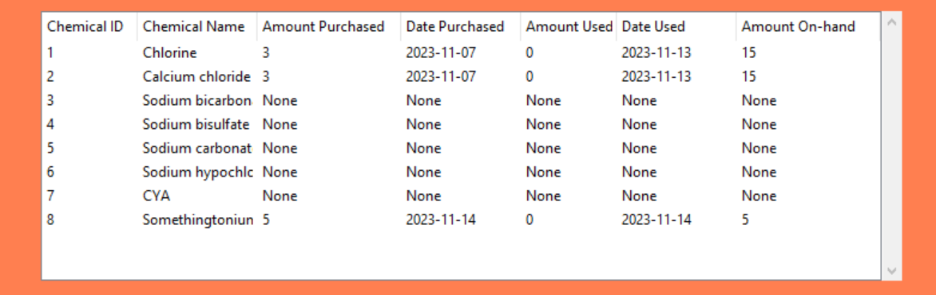

Figure 68 – The treeview of the pool_chemical_supply table after adding the new chemical.

## Removing a Pool Chemical Record

There are two ways to go about removing a pool chemical from the database. The first method is as follows:

1. Select the row in the treeview of the pool chemical you wish to delete.
2. Click the **Remove Record** button under the Actions section of the GUI.

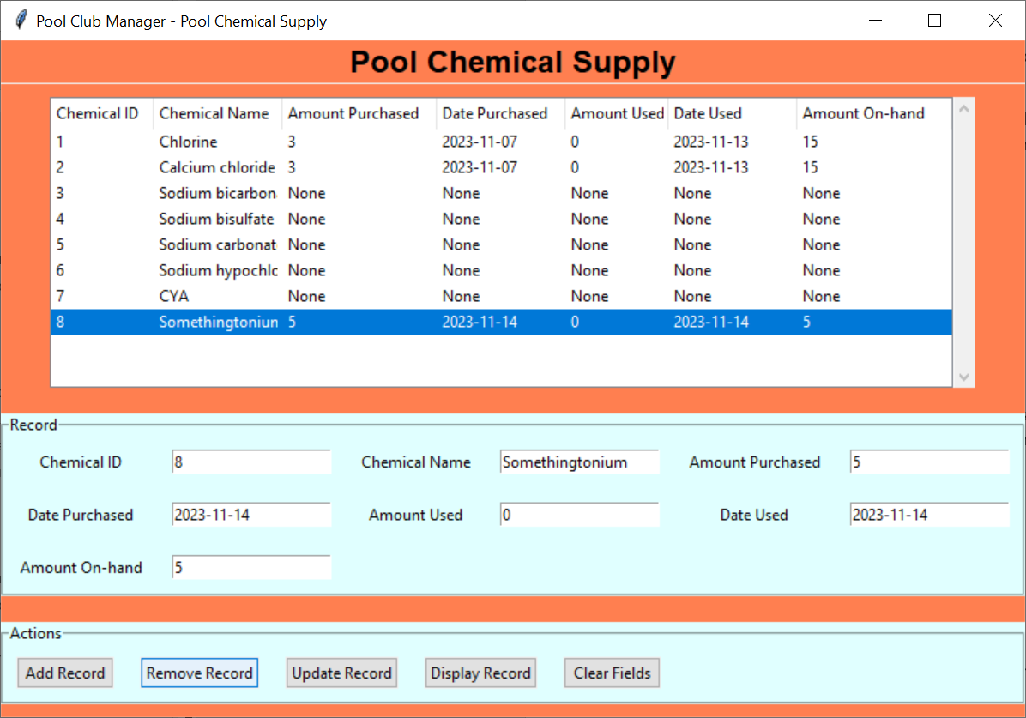

Figure 69 – A visualization of the first method to remove a record.

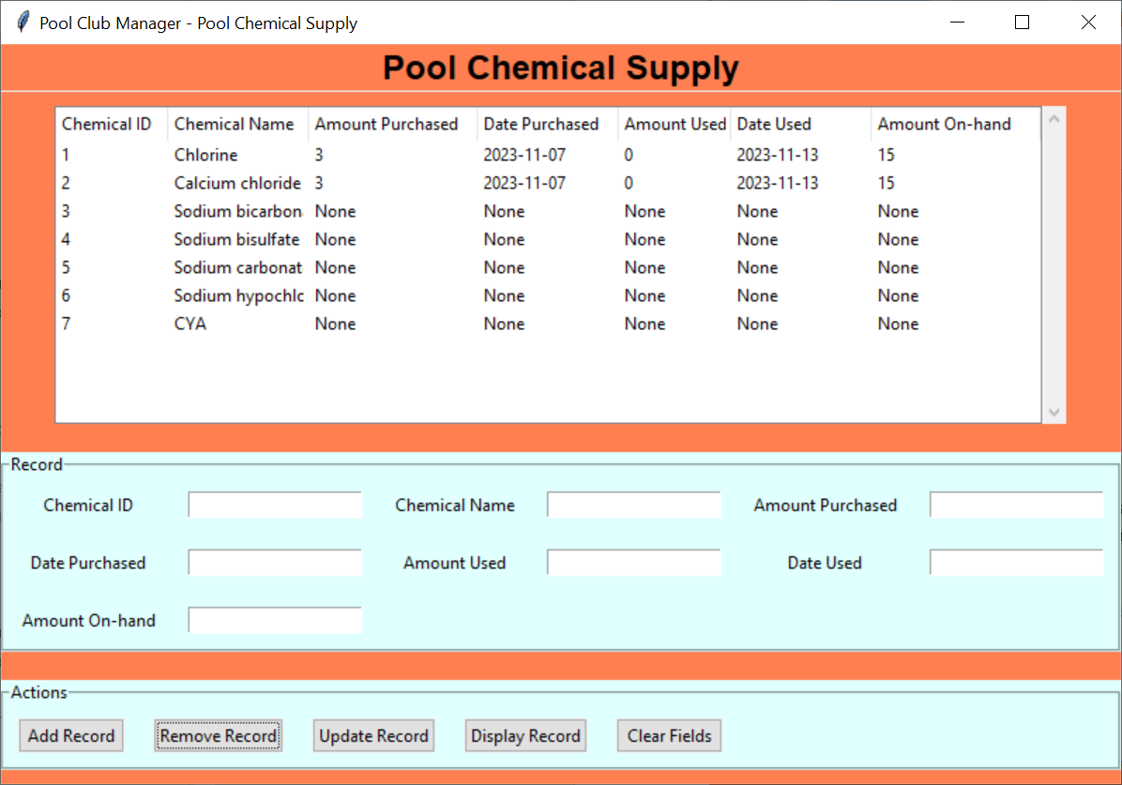

Figure 70 – The treeview of the pool_chemical_supply table after removing a record.

The second method is similar to the first method, but has a different first step:

1. Enter the Chemical ID of the pool chemical you wish to delete from the database.
2. Click the **Remove Record** button under the Actions section of the GUI.

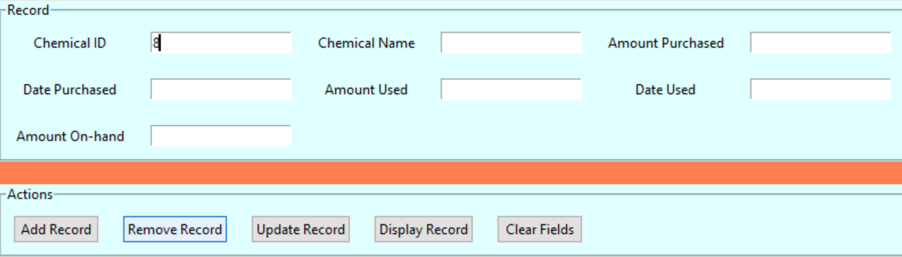



Figure 71 – A visualization of the second method to remove a record and the results.

The pool chemical’s record should now be gone from the database!

## Updating a Pool Chemical Record

First, select the record from the treeview of the pool chemical you wish to update. This should fill up the fields in the Records section of the GUI with the appropriate corresponding values.

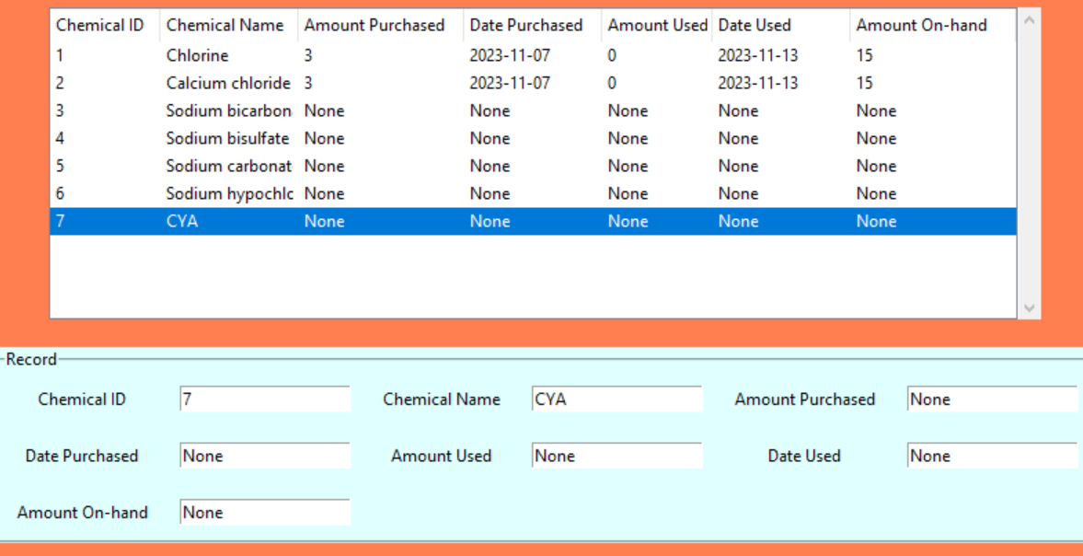

Figure 72 – Selecting a record and the values being filled in the Record fields.

Next, you want to modify one or more of the fields in the Records portion of the GUI *except* for the Chemical ID field. This is because the program is designed to grab in the fields from the GUI and modify the values of the record whose Chemical ID matches the record in the database, thus you may accidently overwrite a record of a pool chemical you didn’t intend to modify.

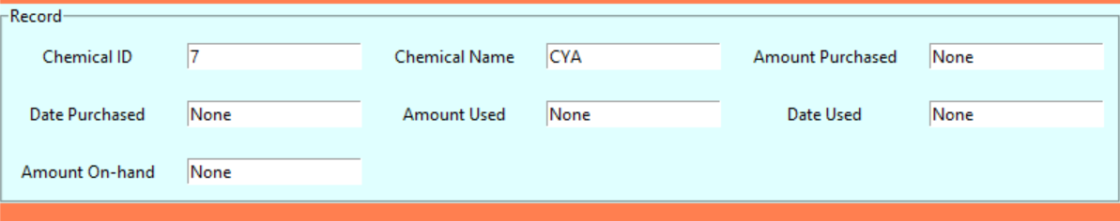

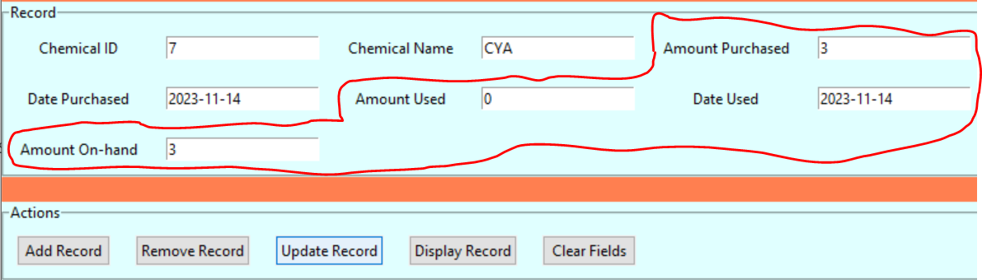

Figure 73 – Updating the record of a chemical, before and after the change. The fields changed are circled for clarity.

Finally, click the Update Record button. The end result should be an updated version of your record from your database being displayed on the treeview.

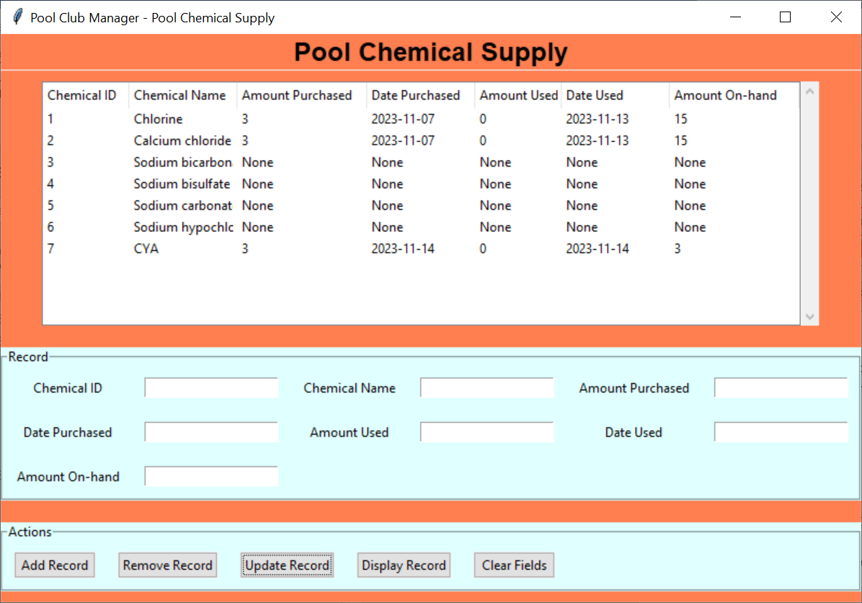

Figure 74 – The updated chemical record.

## Clearing the Pool Chemical Entry Fields

When the fields in the Records section of the GUI have values filled in, simply click the Clear Fields button under the Actions section. They should now be blank.

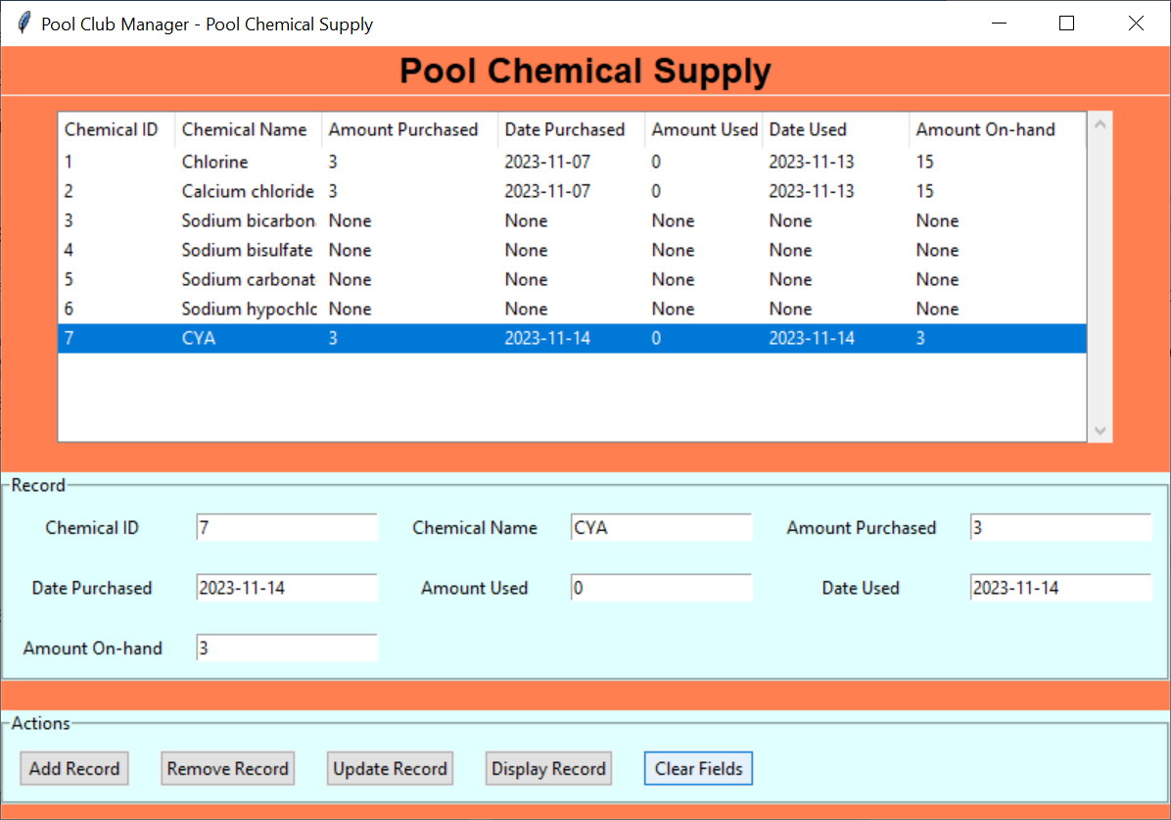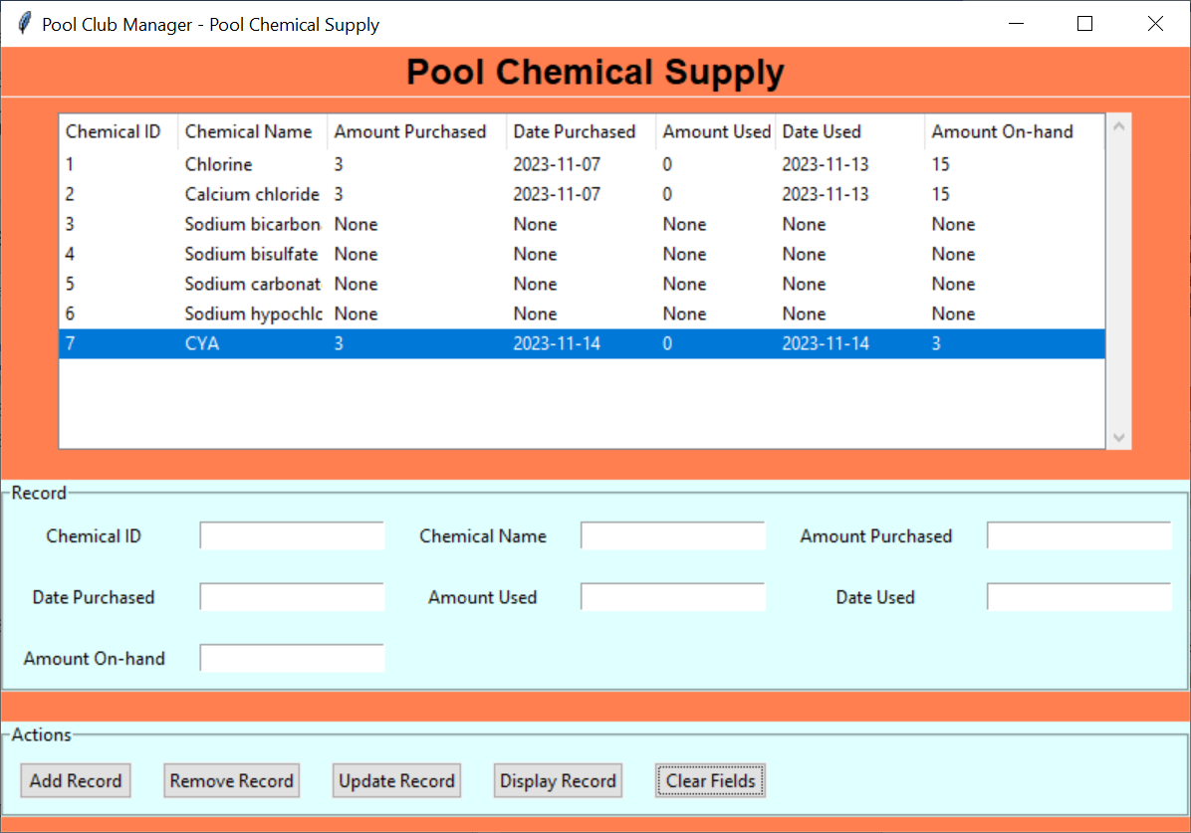

Figure 75 – Clearing the fields, before and after pressing the Clear Fields button.

# Staff Scheduling

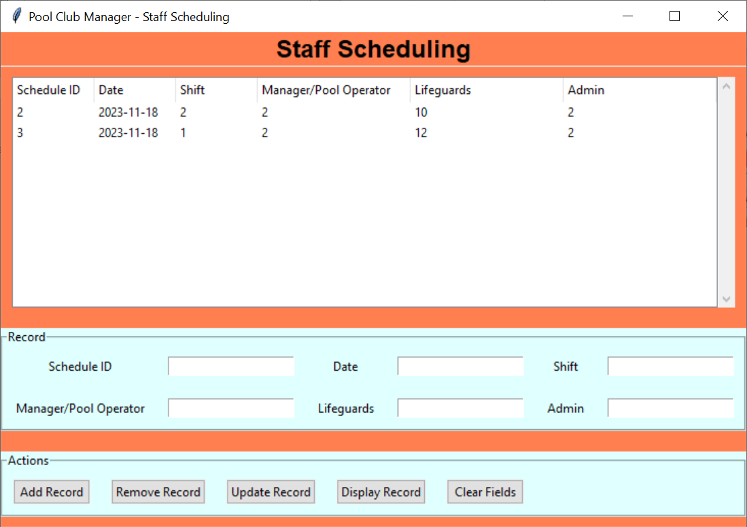

Figure – Staff Scheduling GUI

The Staff Scheduling GUI corresponds to the ‘schedule’ MySQL table in the database. Figure 77 shows an example of the populated database, while Figure 78 shows the various fields that compose the table.

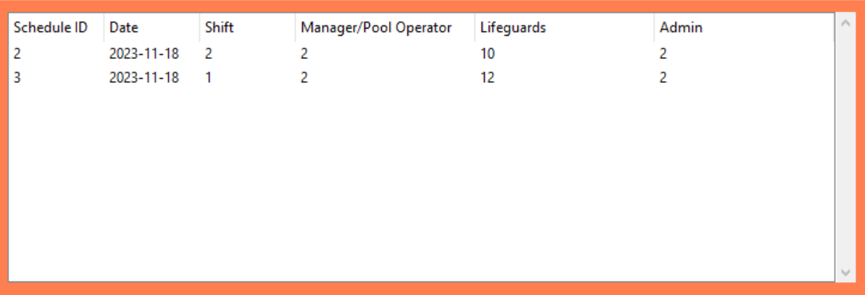

Figure – Treeview of 'schedule' table

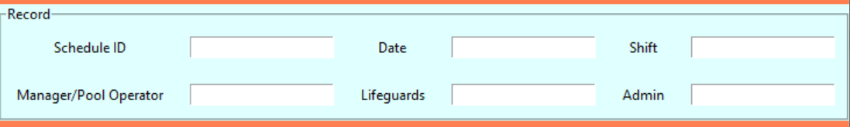

Figure – Input fields and labels

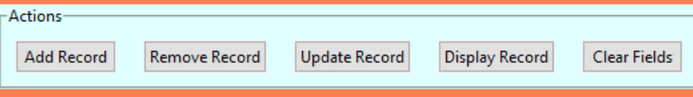

Figure – Action buttons

## Select Treeview Record

To select a treeview record, simply click on any variable in that row and the whole thing will be highlighted. Note that this behavior also automatically fills the record fields below with data corresponding to said record. This is shown in Figure 80 below.

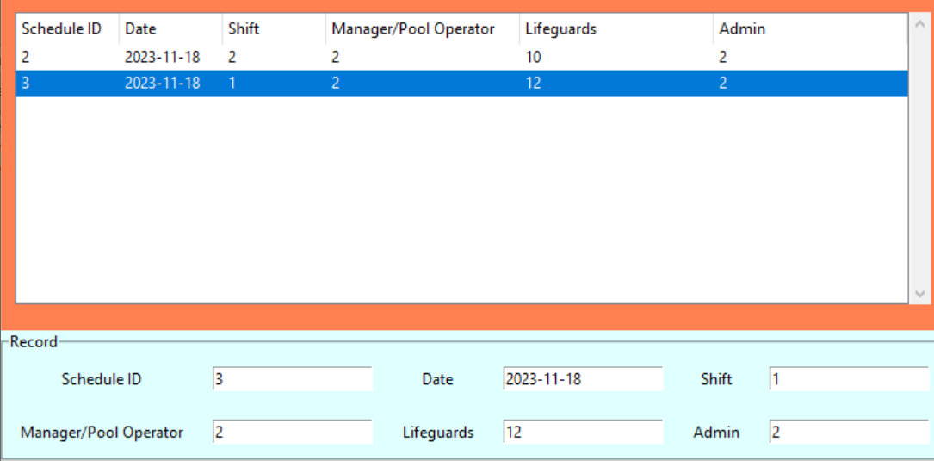

Figure – Selecting the record with the Schedule ID value of '3' in the treeview.

## Adding a Staff Schedule Record

First, you need to fill in the fields for the record of the new staff schedule you wish to add to the database located under the Record section of the GUI. Remember to make the Schedule ID field a unique value. Next, click on the **Add Record** button located under the Actions section of the GUI.

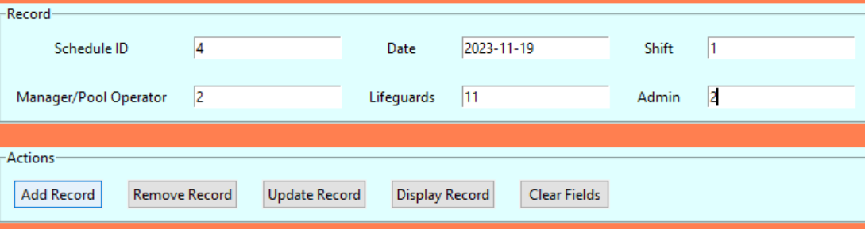

Figure 81 – Adding a scheduled shift with the Schedule ID ‘4’ to the database.

Your new record should now be present in the GUI.

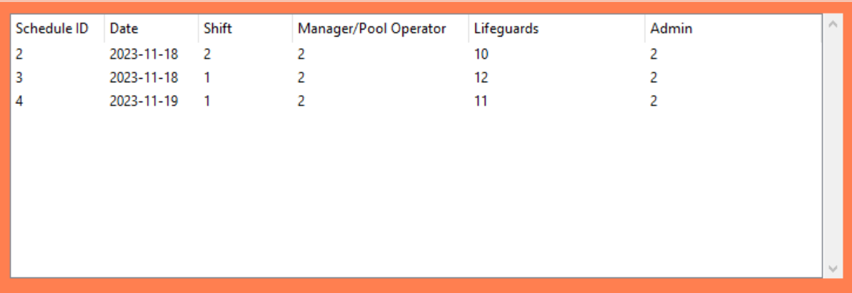

Figure 82 – The treeview of the schedule table after adding the new scheduled shift.

## Removing a Staff Schedule Record

There are two ways to go about removing a staff schedule from the database. The first method is as follows:

1. Select the row in the treeview of the staff schedule you wish to delete.
2. Click the **Remove Record** button under the Actions section of the GUI.

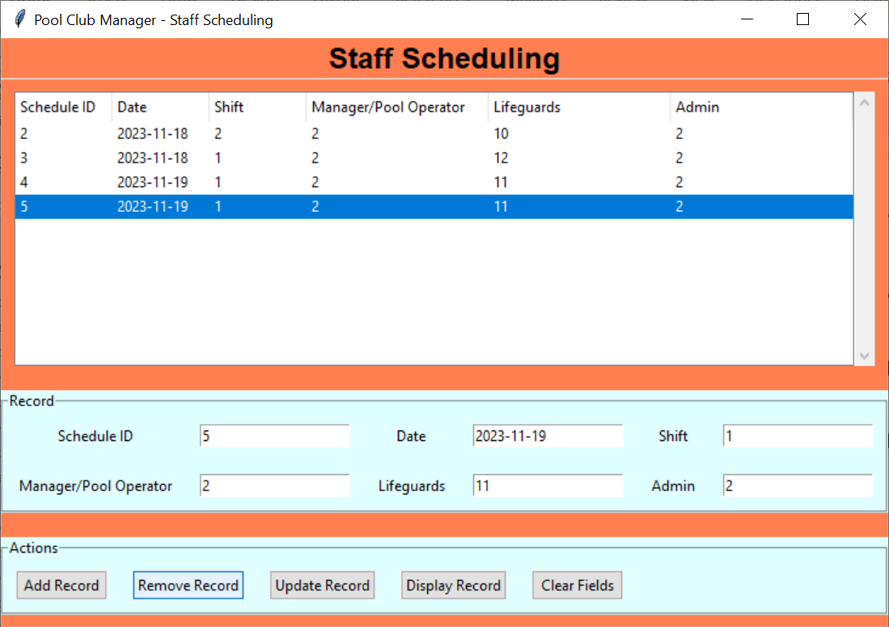

Figure 83 – A visualization of the first method to remove a record.

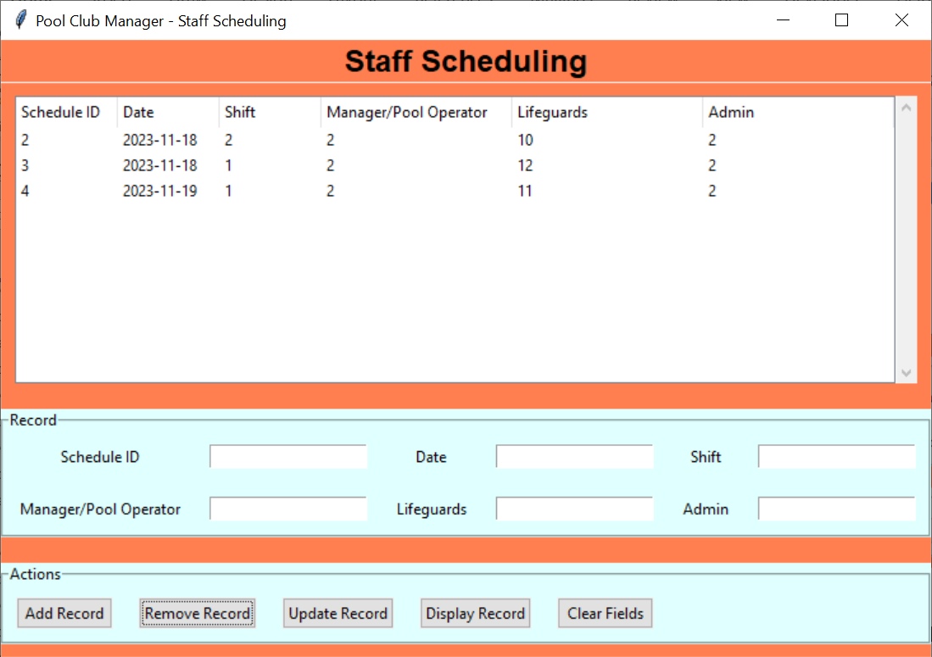

Figure 84 – The treeview of the schedule table after removing a record.

The second method is similar to the first method, but has a different first step:

1. Enter the Schedule ID of the staff schedule you wish to delete from the database.
2. Click the **Remove Record** button under the Actions section of the GUI.

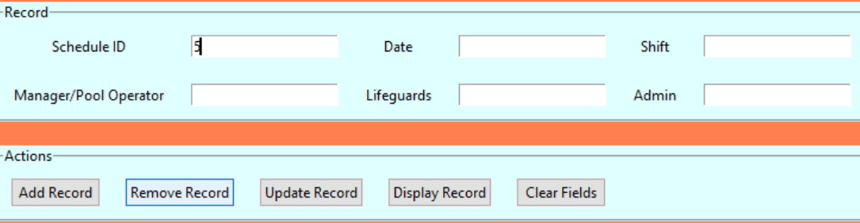



Figure 85 – A visualization of the second method to remove a record and the results.

The staff schedule’s record should now be gone from the database!

## Updating a Staff Schedule Record

First, select the record from the treeview of the staff schedule you wish to update. This should fill up the fields in the Records section of the GUI with the appropriate corresponding values.

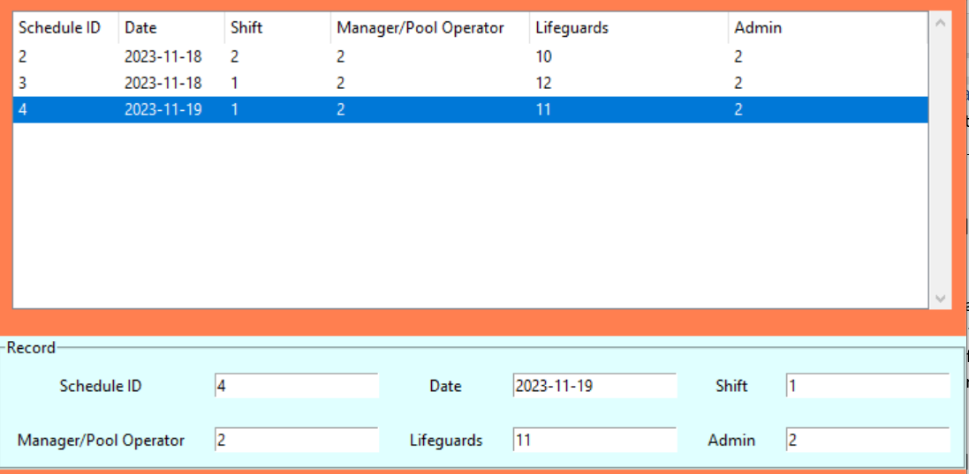

Figure 86 – Selecting a record and the values being filled in the Record fields.

Next, you want to modify one or more of the fields in the Records portion of the GUI *except* for the Schedule ID field. This is because the program is designed to grab in the fields from the GUI and modify the values of the record whose Schedule ID matches the record in the database, thus you may accidently overwrite a record of a staff schedule you didn’t intend to modify.

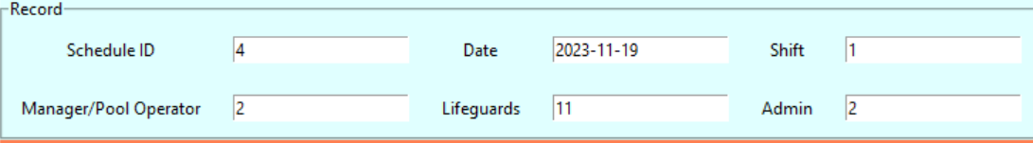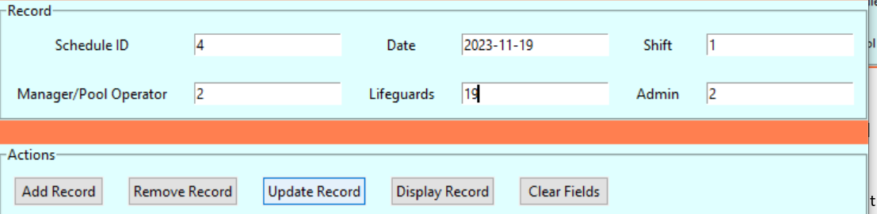

Figure 87 – Updating the record of a shift, before and after the change.

Finally, click the Update Record button. The end result should be an updated version of your record from your database being displayed on the treeview.

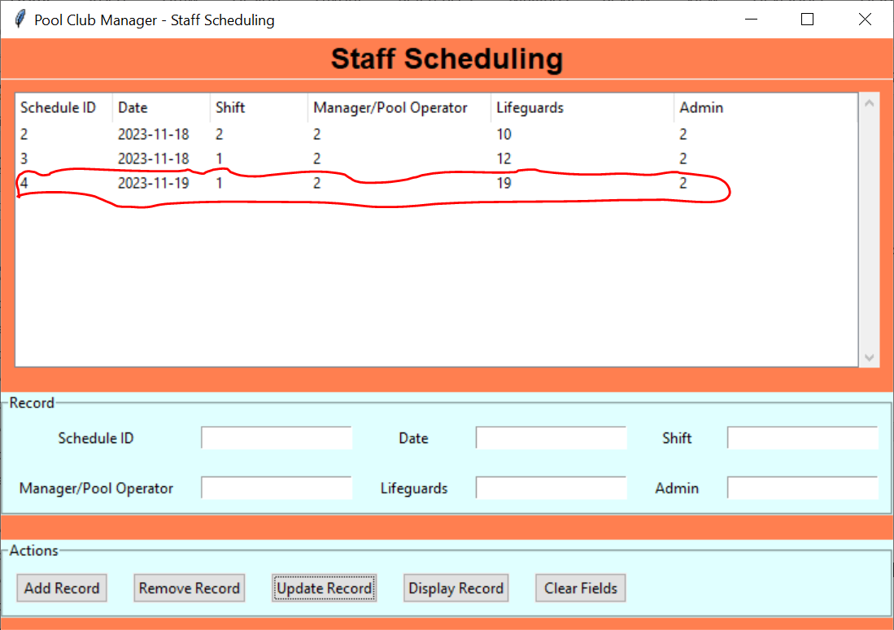

Figure 88 – The updated shift record, circled for clarity.

## Clearing the Staff Schedule Entry Fields

When the fields in the Records section of the GUI have values filled in, simply click the Clear Fields button under the Actions section. They should now be blank.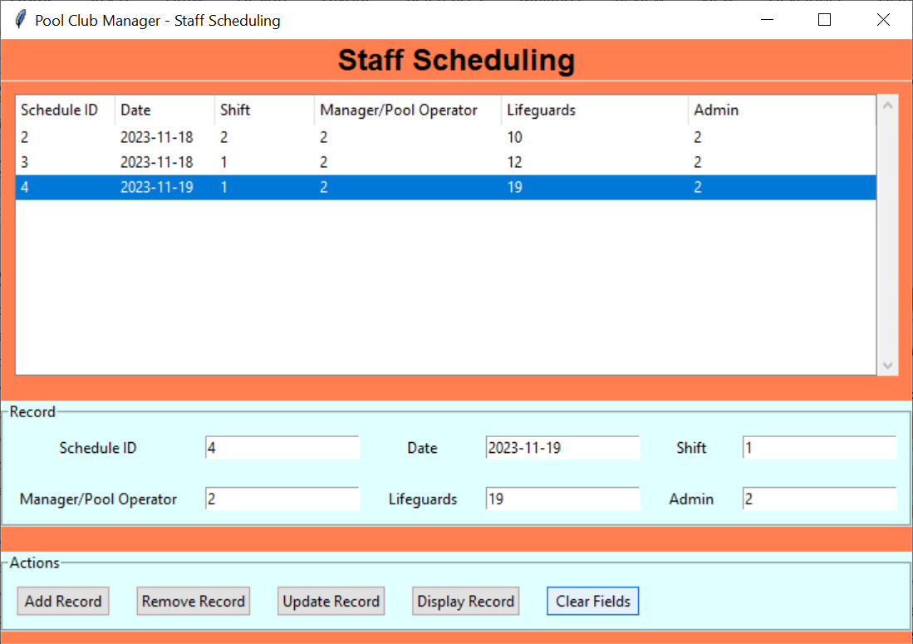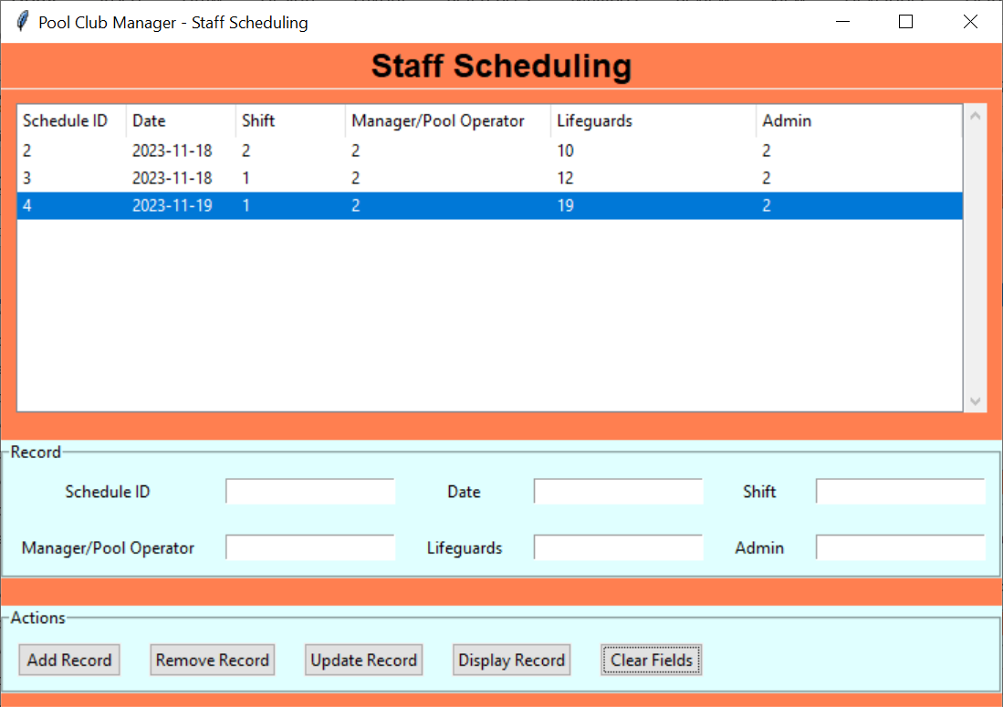

Figure 89 – Clearing the fields, before and after pressing the Clear Fields button.